**PNEUMONIA DETECTION THROUGH X-RAY**

**PYTHON PROJECT**

**Final Report**

**TEAM 6**

**B2N**

**MEMBERS:**

KOLLURI, NIKHITHA(12)

INAKOLLU, SRI NAGA BHUVANESHWARI(9)

DUKKIPATI, SRI SAI NITHIN CHOWDARY(4)

**INTRODUCTION**

It is very important for all the countries to perform some tests to know whether their people are suffering from any pandemics. Now-a-days pandemic crisis is progressing rapidly. Unfortunately, the capacity of the testing centres is very low in most of the countries. Usually, pneumonia is caused by viruses, bacteria and sometimes by microorganisms. We can confirm the diagnosis by taking the chest x-ray or blood cells, so here we are using chest x-rays. It is hard for every person to get the appointment of the doctor due to the evolution of the new virus Covid-19. Through this application, we want to give some mental peace for those who are suspecting whether they suffer from pneumonia or not, and through this, we can also have a chance to predict whether a person is affected by corona or not (as corona mainly affects respiratory system). All this provides us a motivation to choose this dataset and build an application which detects whether a person is suffering from pneumonia or not, as early diagnosis would be an important factor to be treated successfully.

In this project we will be predicting whether there exists pneumonia in the given image. We do this by taking the x-rays of some healthy persons and compare them with the x-rays of the people who are suffering from pneumonia. Then we train the model and will predict whether the person is suffering from pneumonia or not. In the present world, the doctors are very busy treating people with covid-19, through this application we provide computer-aided diagnosis system which would reduce the burden of clinicians. We can also have a chance to say whether a person is suffering from COVID or not because COVID virus mainly affects the respiratory system. We have opted for CNN motivated deep learning algorithms, since they have been used as the standard and best choice to classify the medical images.

**Objectives:**

* To train a model in a way, such that it predicts whether the X-ray uploaded has Pneumonia or not.
* To build an angular website that takes in the image as input and communicates with model which is already built and displays the prediction.
* To deploy the model on some cloud platform, so that the website can call the model API.

**Features:**

* A model which is trained to predict the detection of Pneumonia from the given Chest X-ray.
* A website that takes X-rays and displays the predicted results.

**GIT Links:**

* **Model :** [**https://github.com/ntihindukkipati/CS5590_Python_DL.git**](https://github.com/ntihindukkipati/CS5590_Python_DL.git)
* **Heroku: https://damp-inlet-85753.herokuapp.com/**

**Technologies Used:**

* Python
* Flask
* HTML5
* JS
* CSS3

**Python Concepts Used:**

* From Keras
  + Convolutional Neural Networks
  + Dense
  + MaxPooling
  + Early Stopping
  + Image Generator
  + Wandb
* Flask
  + Requests
  + RenderTemplates
  + Request
* OpenCV2
  + ImRead
  + ImShow
  + ImResize

**Here we are showing the previous version(Version 1), the mistakes we have done and the present version(Version 2) where we have corrected the mistakes and compiled a new model.**

**Version - 1**

**DATASET:**

We have used Kaggle’s data set for Image classification using chest x-ray

**STEP 1: (Reading the data set and pushing into List)**

We are building our model in google COLAB so for this we have uploaded the image data set in to google COLAB.

1. we have used glob in-order to retrieve the image data from google drive. (in order to get all images of same pattern)

TRAINING DATA

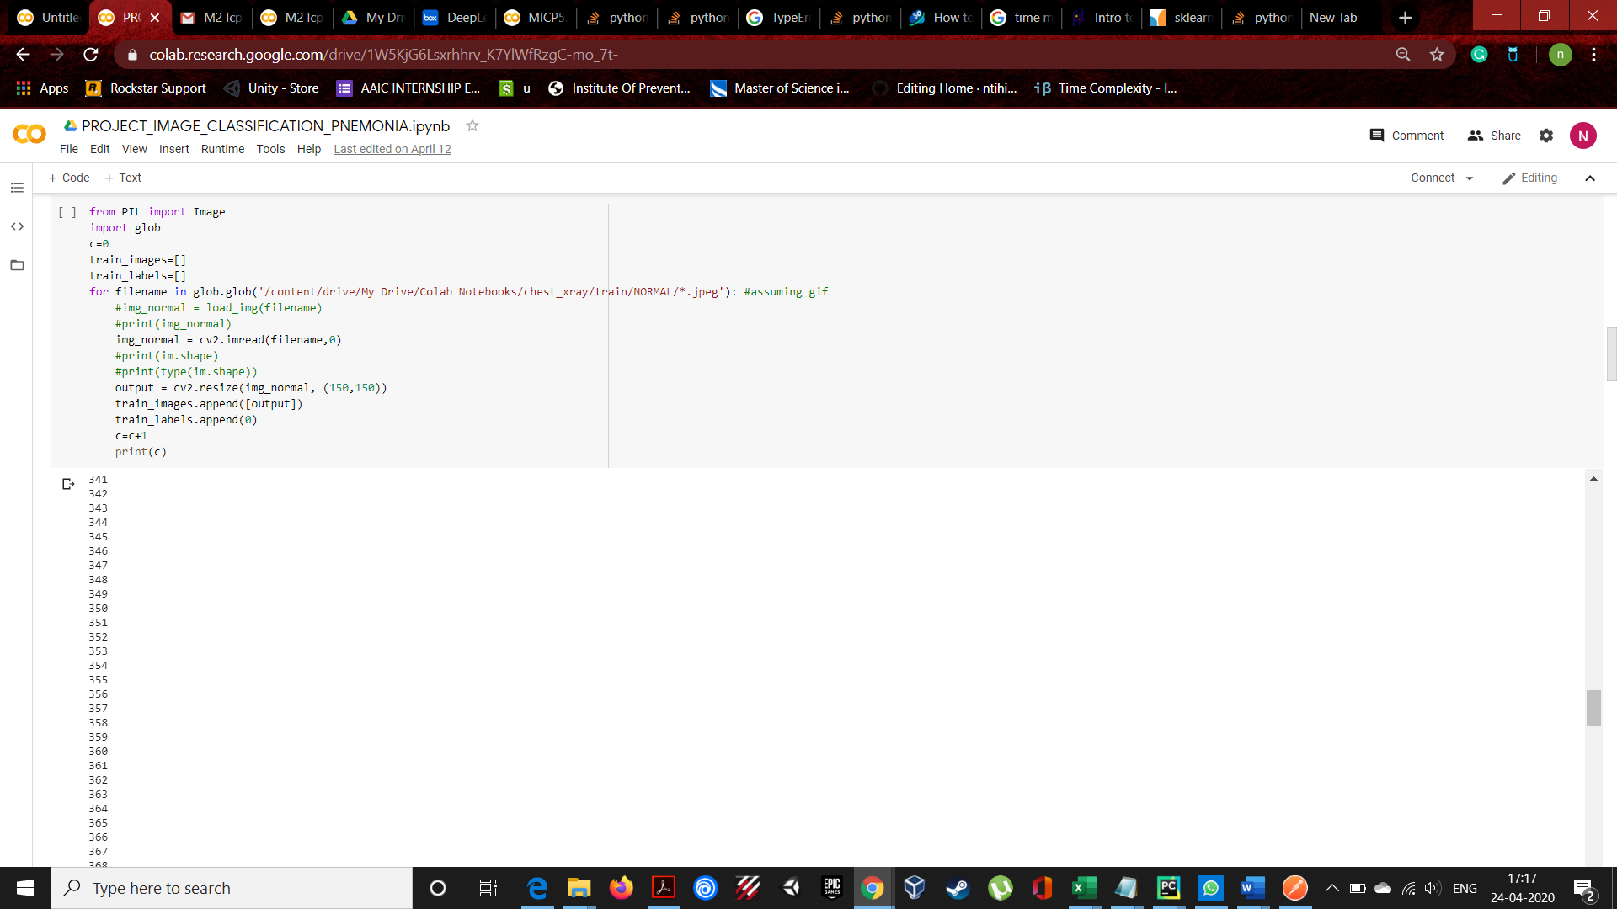

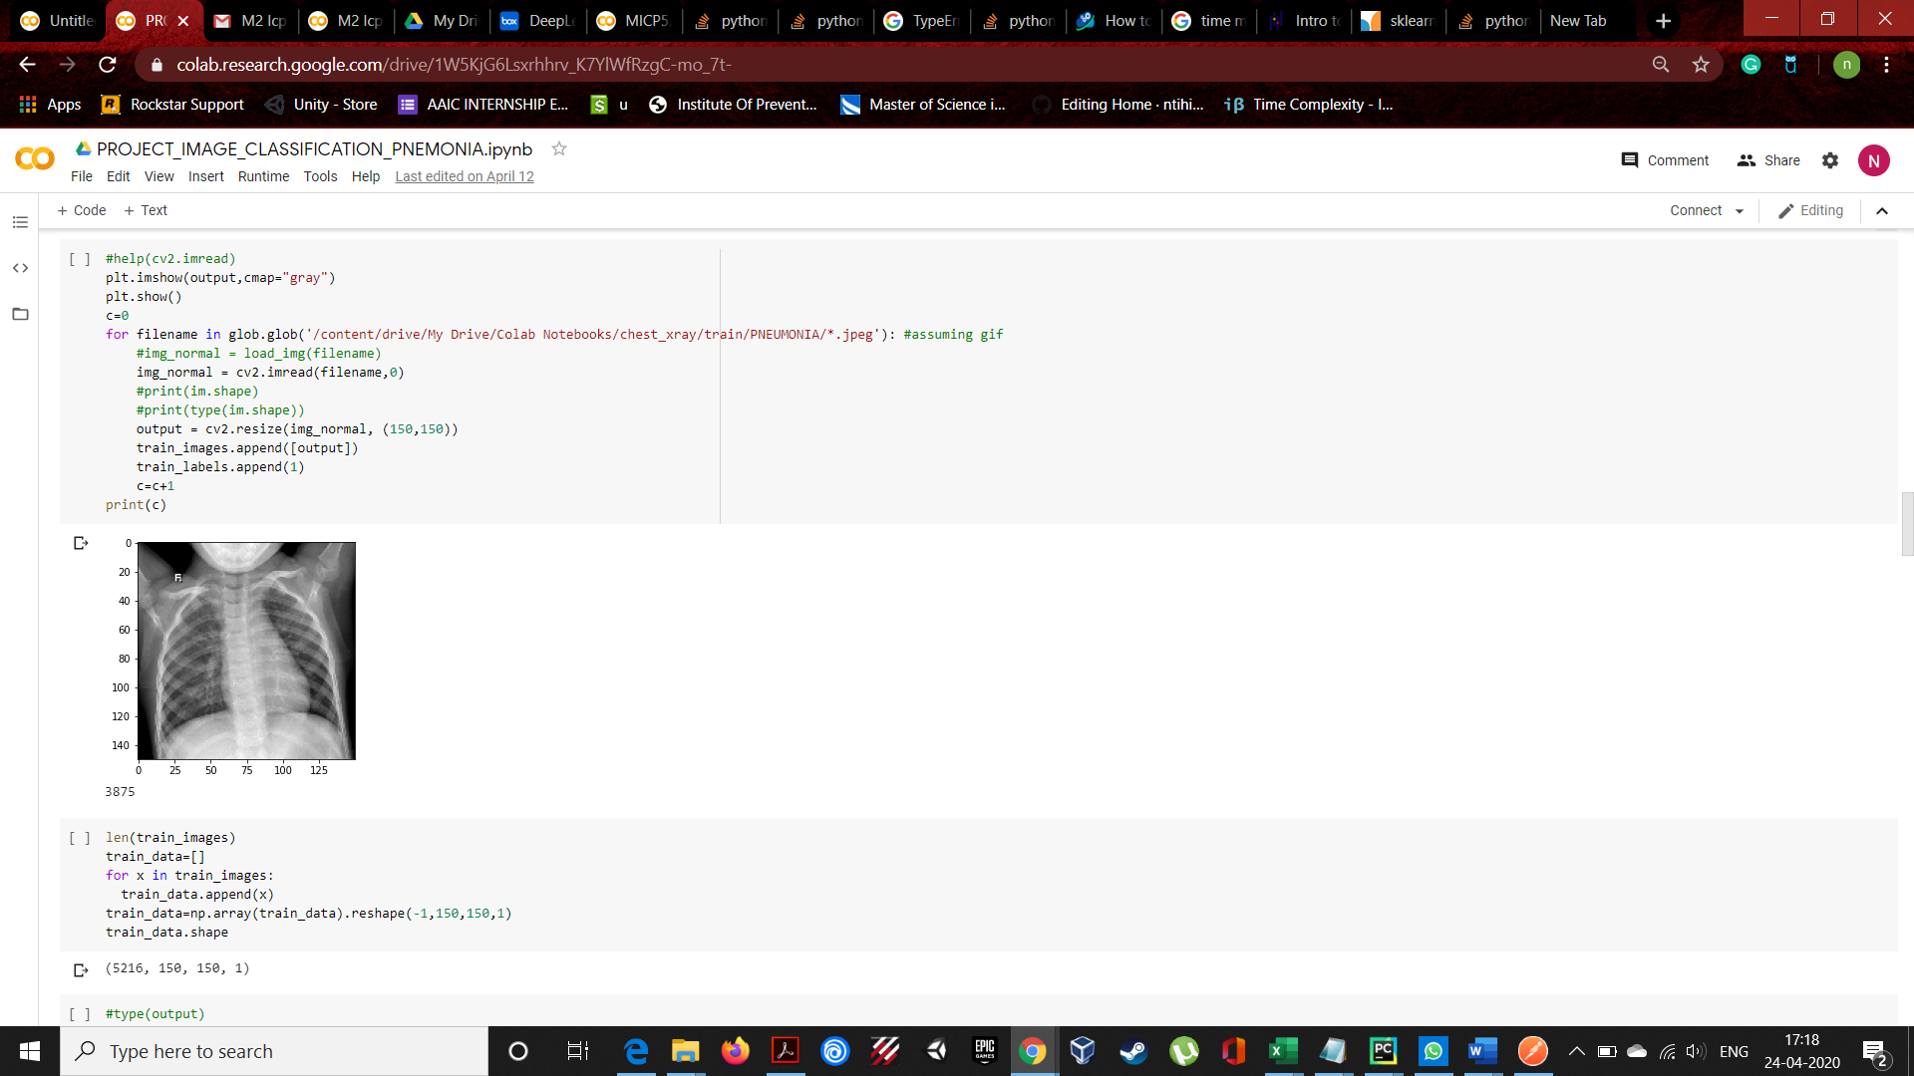

TEST DATA

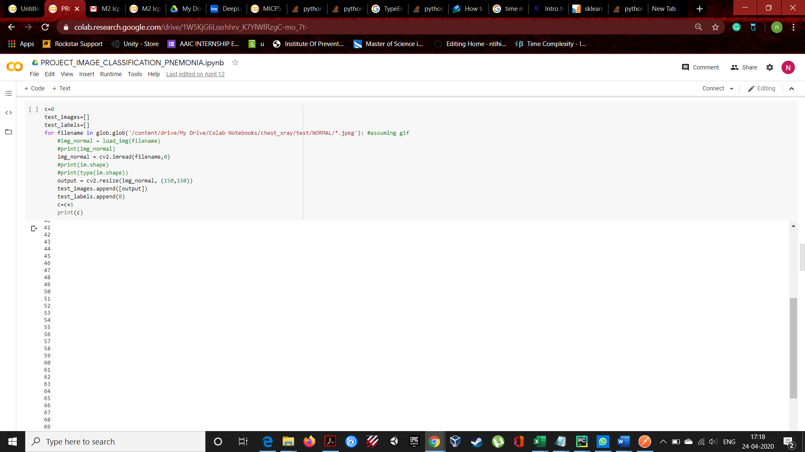

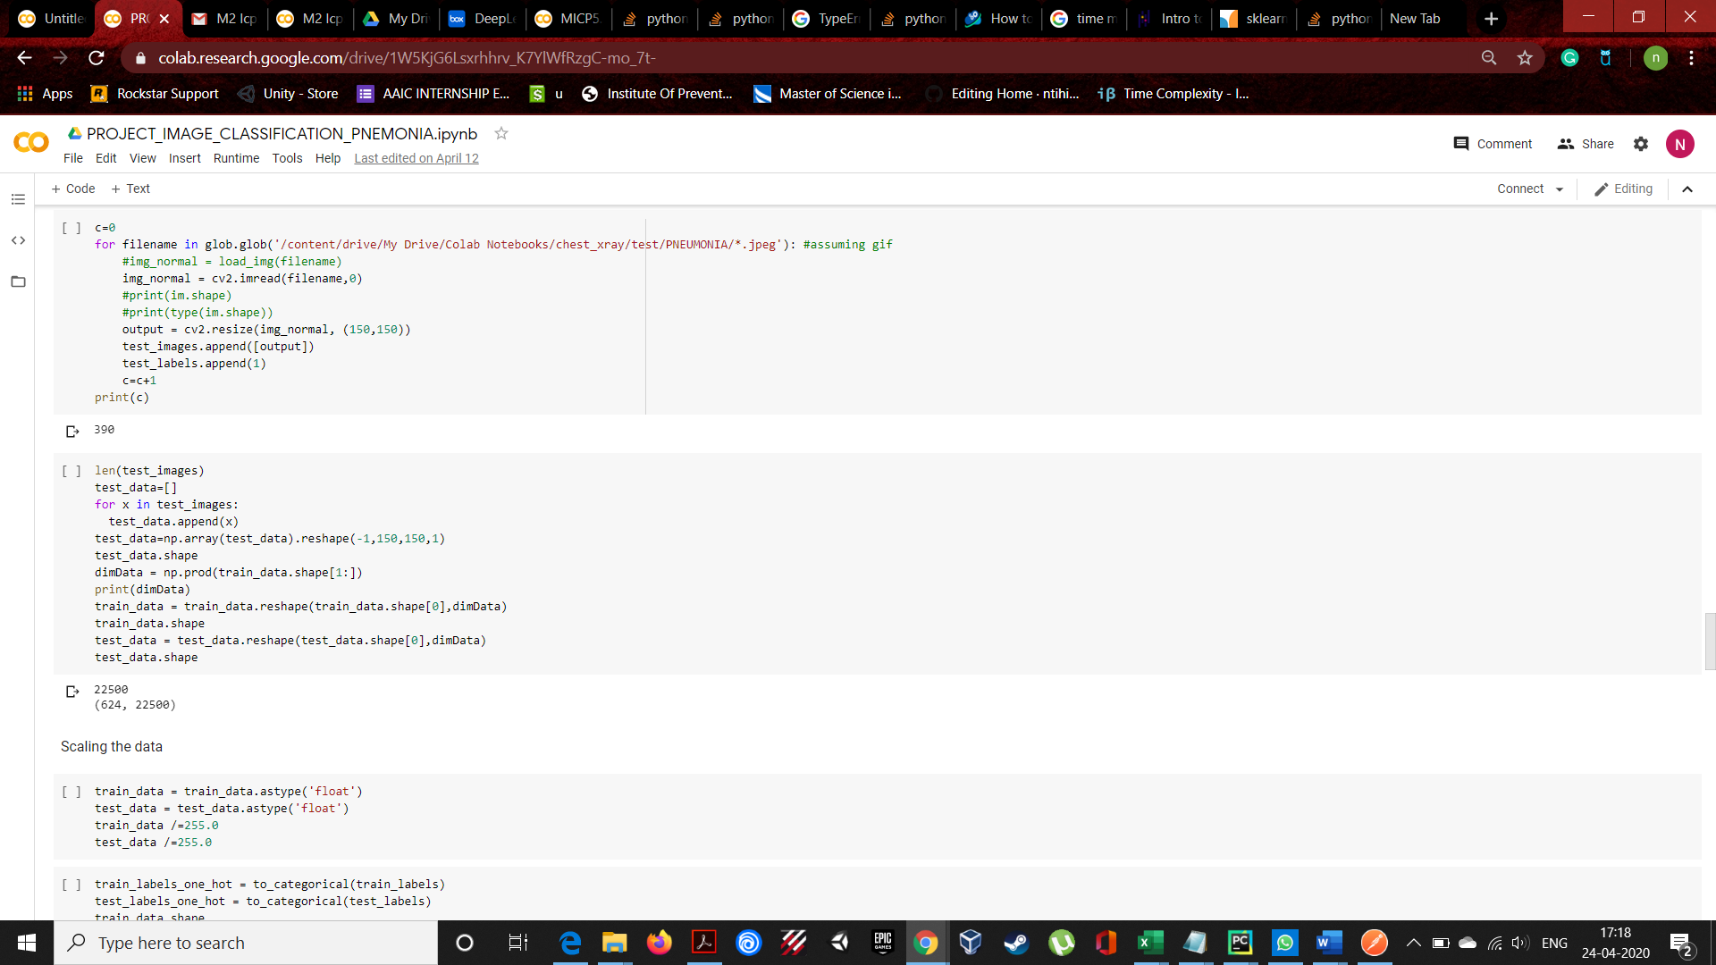

**NOTE**

We have used cv2.imread to read the image data and we have also converted into 1 channel in-order to reduce complexity. We have resized the image to 150,150,1 shape.

**STEP 2:**

Converted the list into numpy to convert the matrix form of 1 image to 1 dimension array.



**STEP 3:**

Scaled the training data and test data by dividing each pixel value by 255.0 in order to reduce the complexity and to get better accuracy.

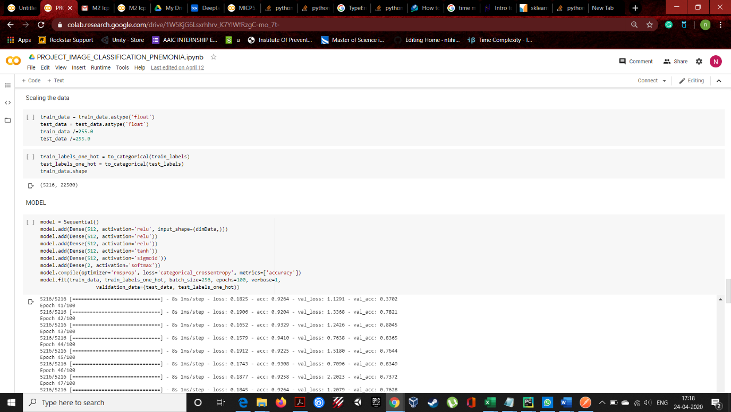

**STEP 5:**

Builded the model

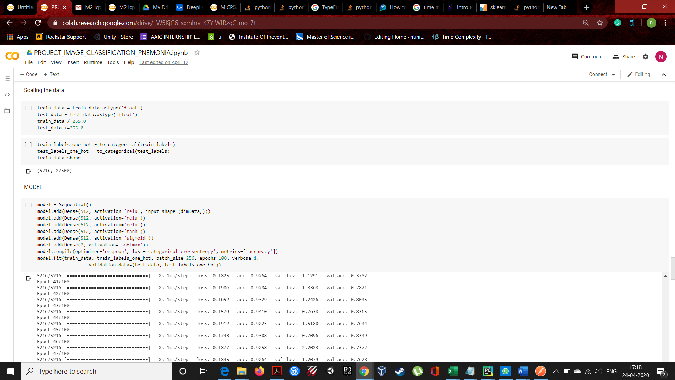

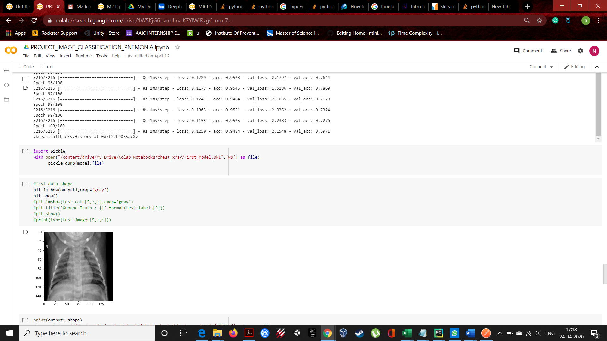

**NOTE:**

We have got an accuracy of 94% and validation of 69%. The loss is too high in the both ends.

**STEP 6:**

We have saved the model using pickle library.



**STEP 7:**

We have used flask frame work in-order to create a API.

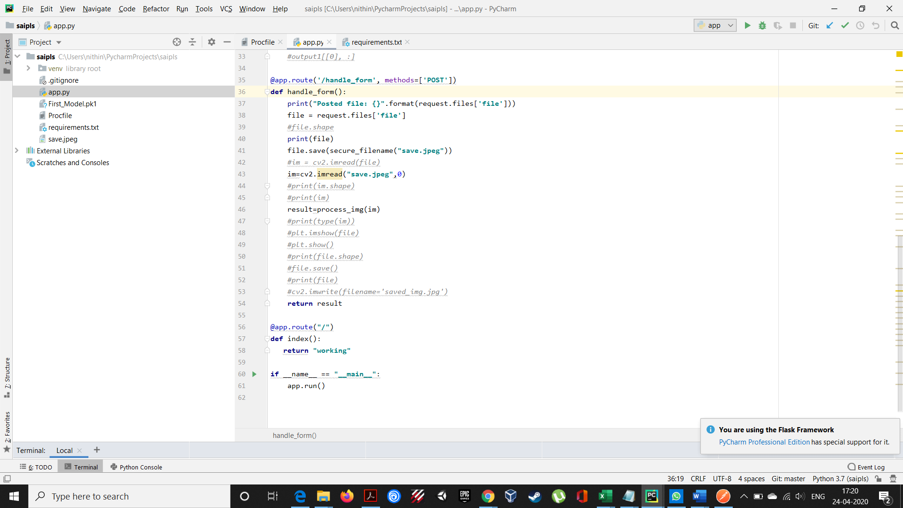

In-order to predict we need to convert the image format to feed into our model. So, for that we have used the same pre-processing technique in-order to convert received image.

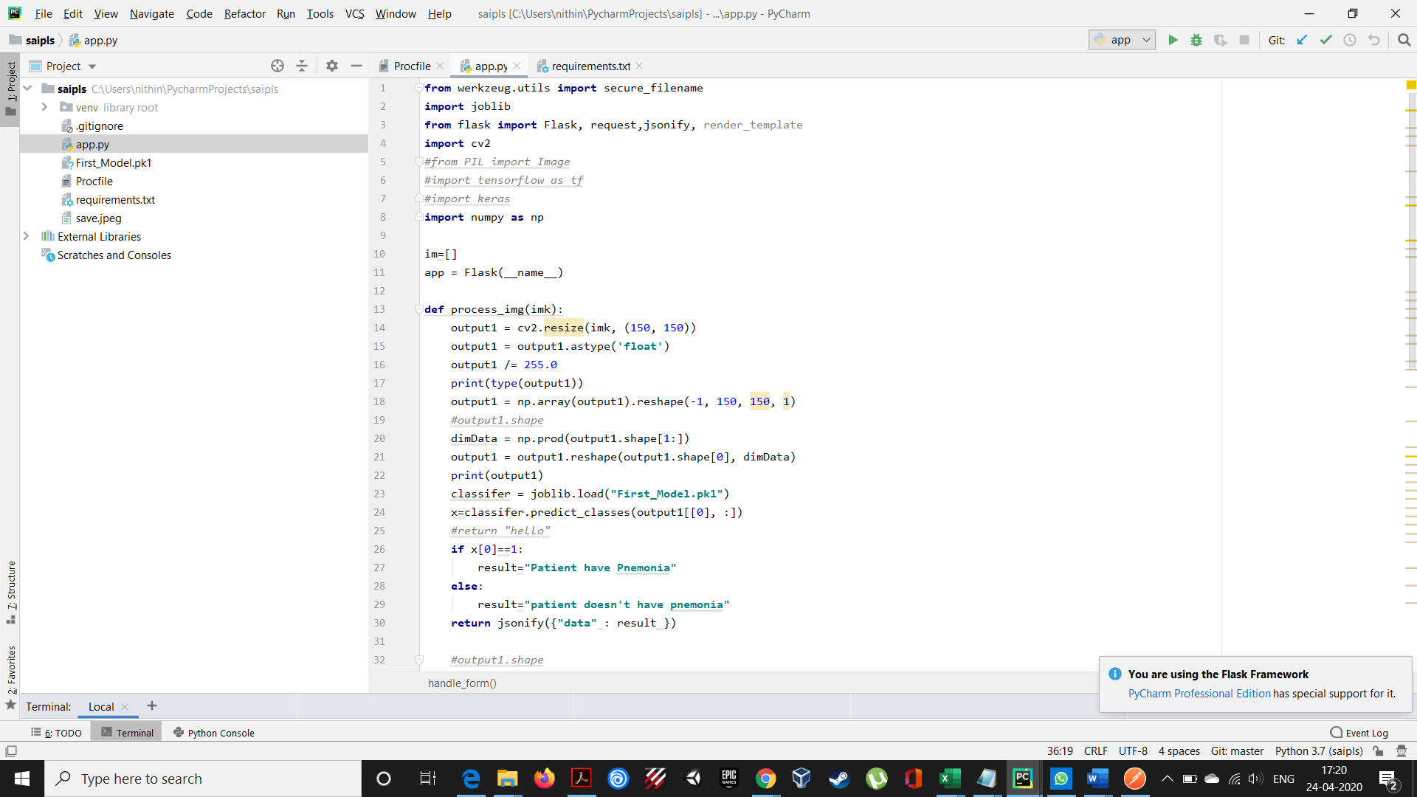

**STEP 8:**

We have deployed this into HEROKU CLOUD in-order to make it a rest service so that it can be useful for us to use in our angular application.

LINK:

GET REQUEST:

<https://calm-peak-20297.herokuapp.com/>

**POST REQUEST:**

<https://calm-peak-20297.herokuapp.com/handle_form>

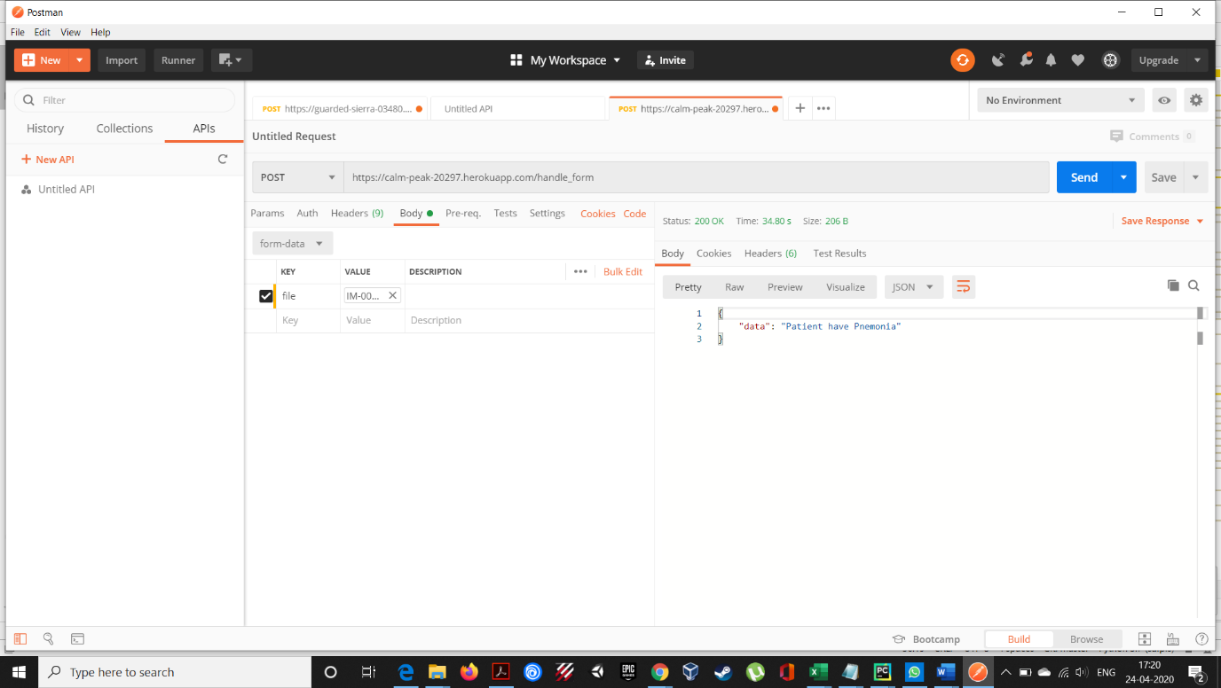

**MISTAKES THAT WE HAVE LEARNED:**

1. Shuffle the data before feeding into model. In the first version we haven’t shuffle the data which has made our model biased.

2. We were not fully aware of the convolutional neural network.

**VERSION 2:**

**STEP 1:**

Importing the libraries and importing the images from the google drive

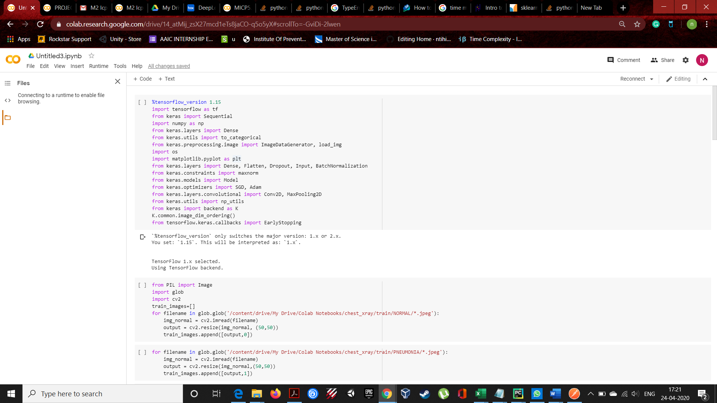

READING THE TEST DATA TRAIN DATA INTO LIST

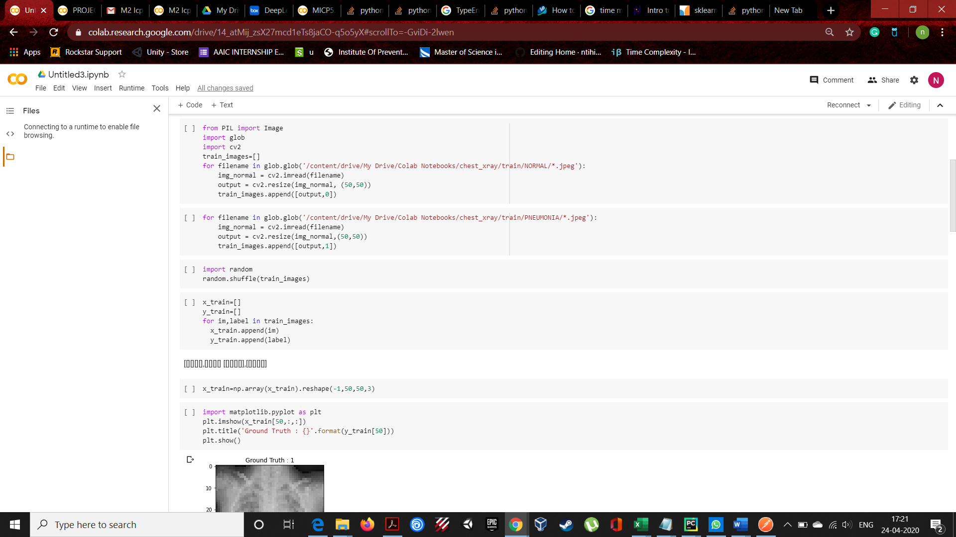

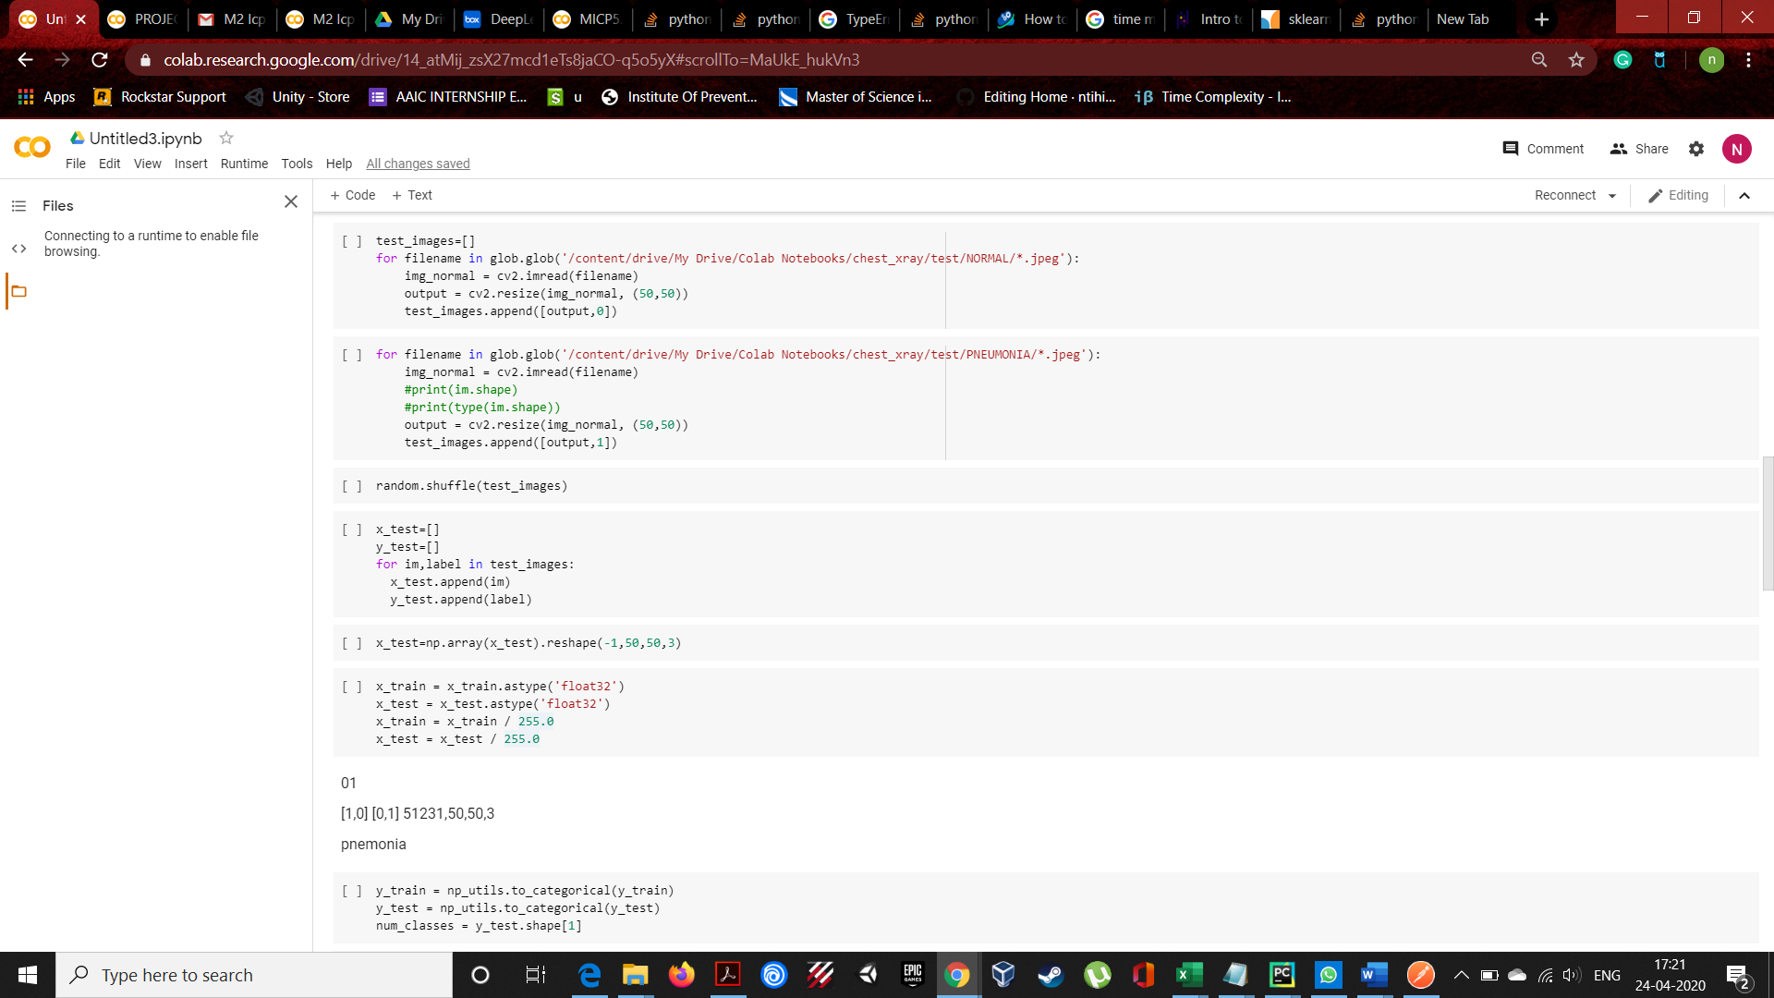

**STEP 2:**

Shuffling the data in order to conflict bias in our model. And we have pushed the list data into nd.array to feed into our model





We have reshaped the image size to 50,50,3. We reduced the size in order to avoid crash while running epochs.

**STEP 3:**

Covert the labels to categorical values and scale the images by dividing each pixel by 255.

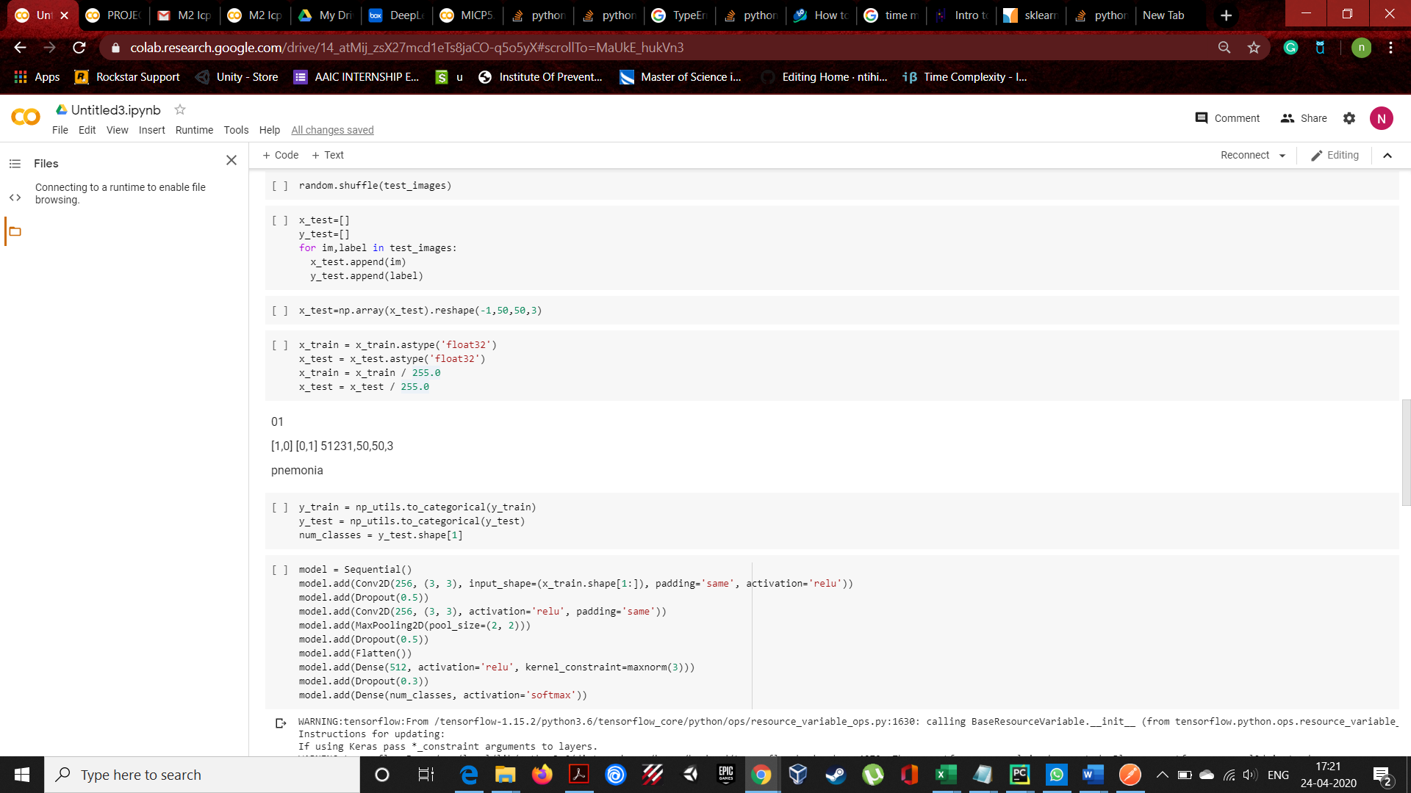

**STEP 4:**

BUILD THE MODEL



**STEP 5:**

Used the call back function to reduce overfitting in the model. Here we are observing the for 5 epochs whether my validation loss in decreasing (1e-1=0.001).

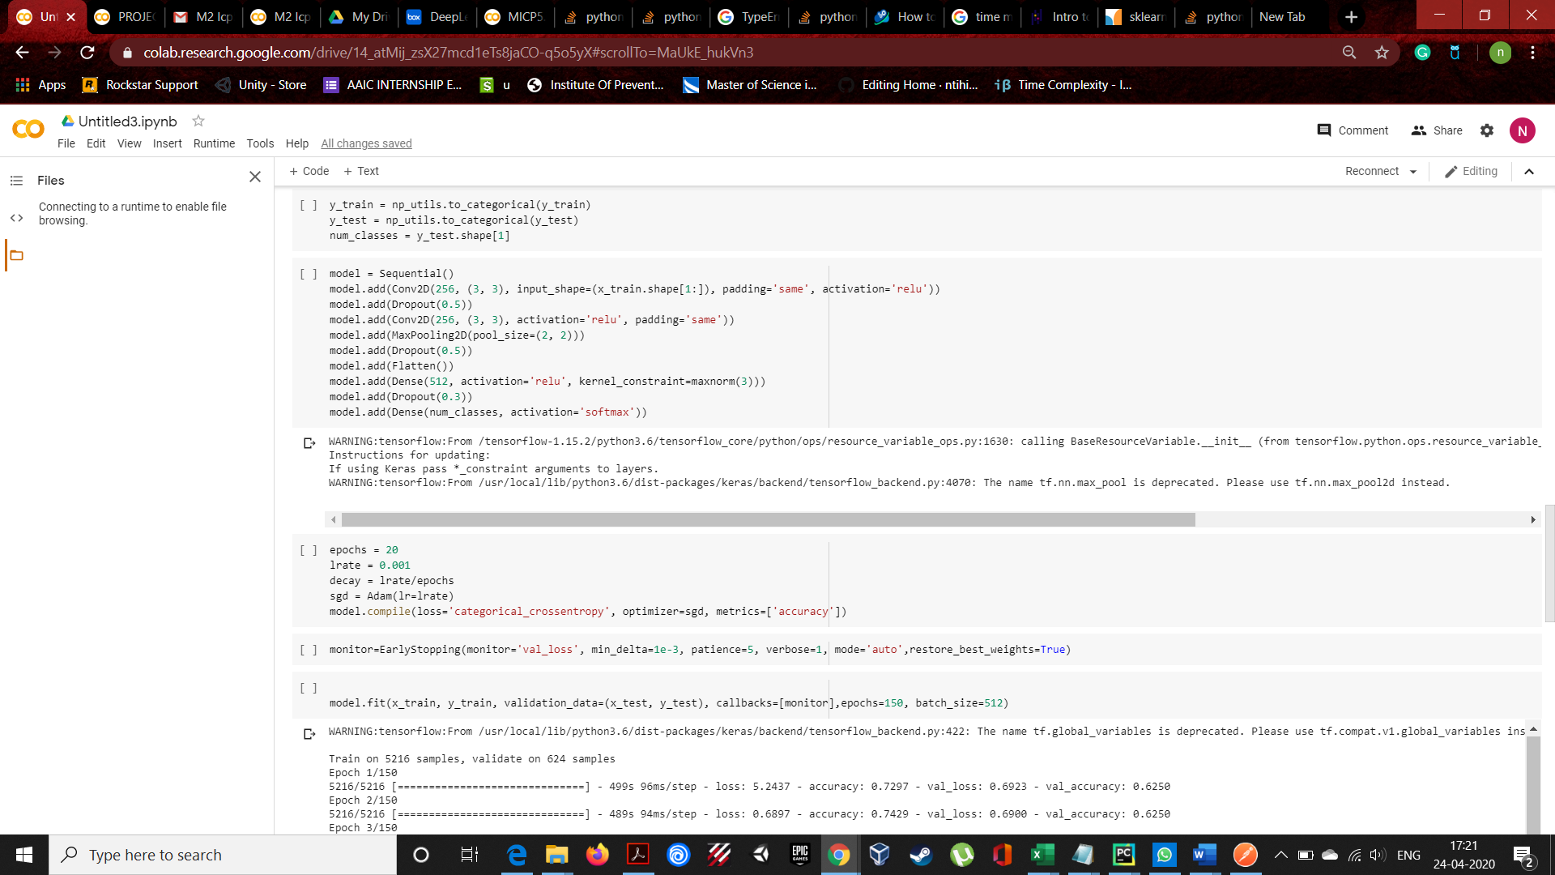

**STEP 6:**

We have got an accuracy of 74% and val_acc of 62% and loss is to high which is leading in wrong prediction.

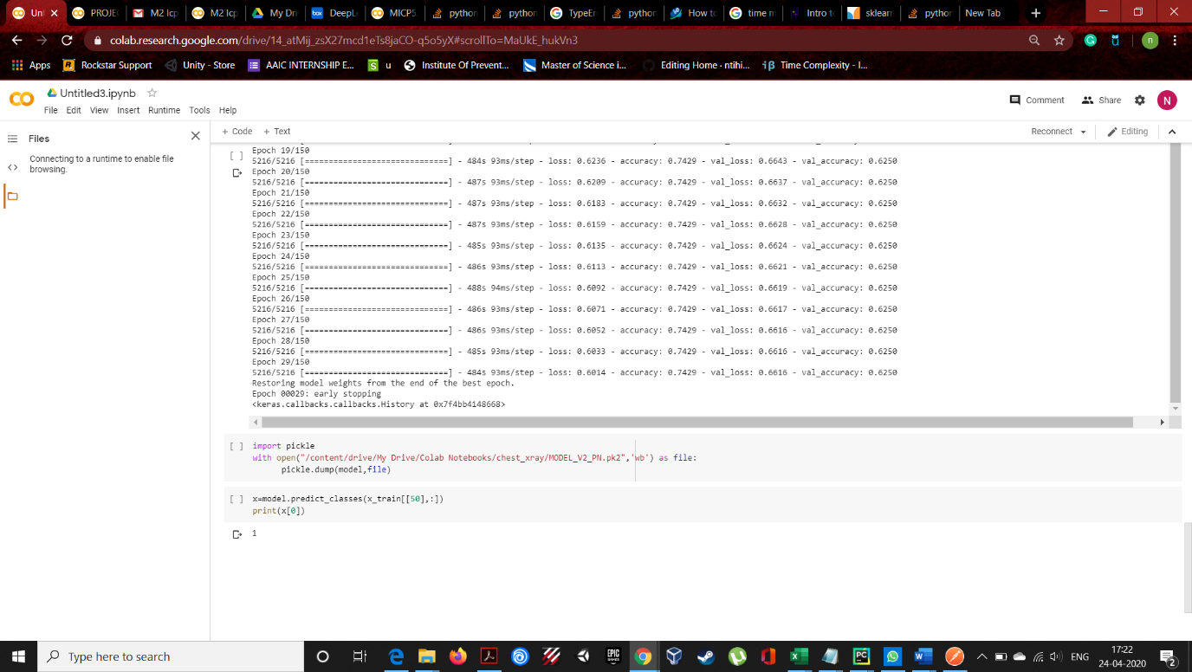

We have saved our model using pickle library.

**STEP 7:**

We have used flask frame in order to create web UI

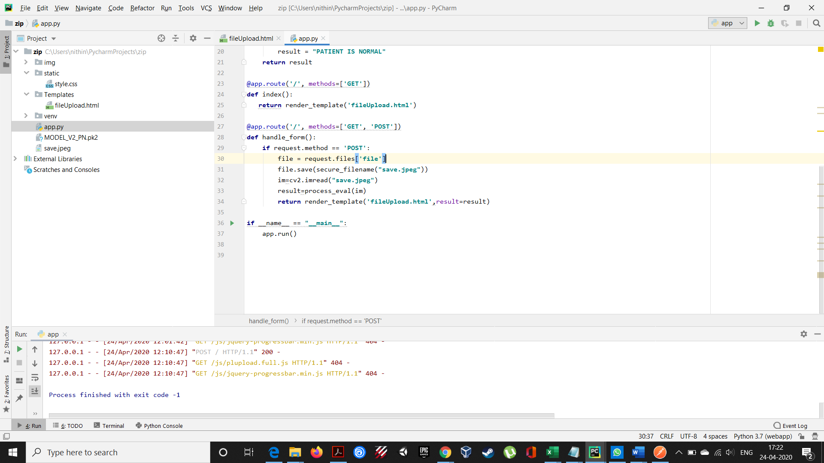

For feeding received image we need to convert that image into feedable format.

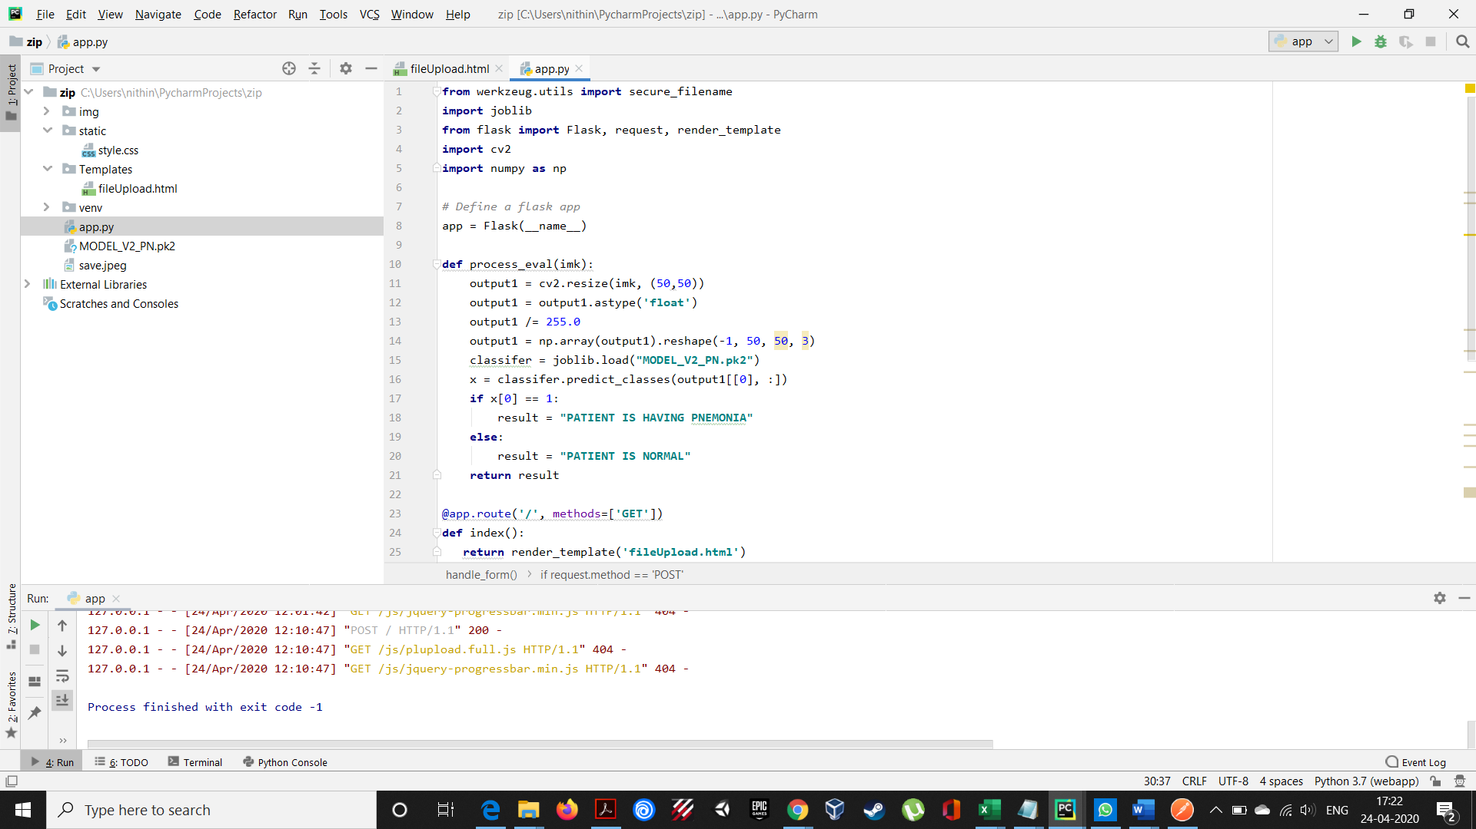

Converted the image into size of 50,50,3 and passed through our model for prediction.

1. local host 127.0.0.1.5000/

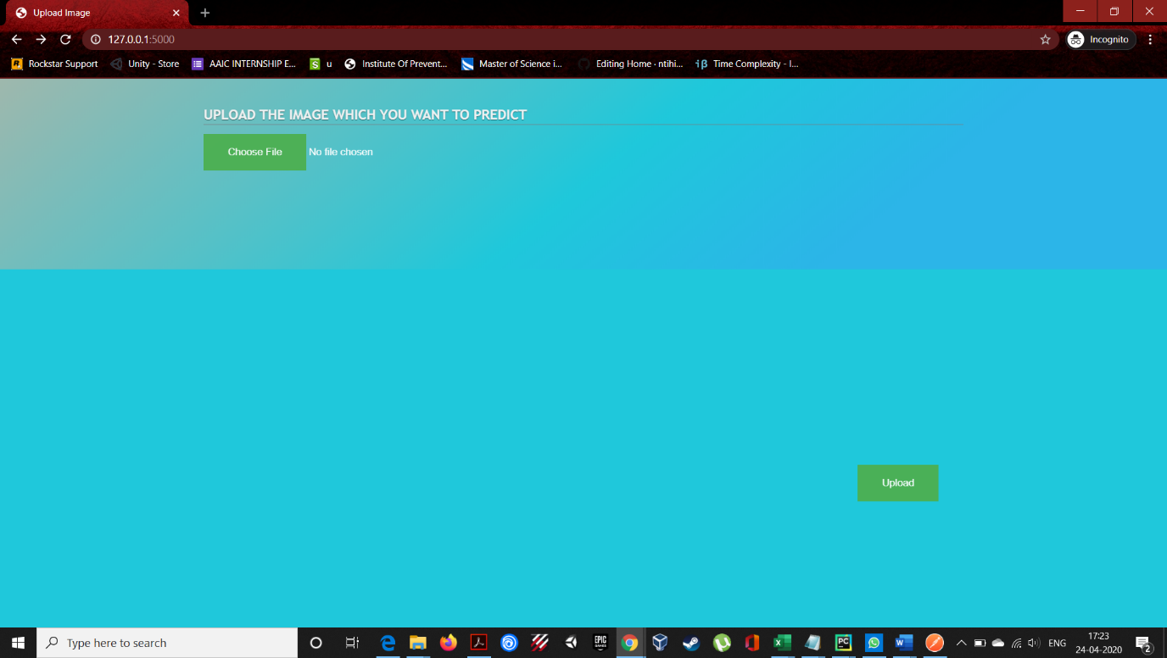

2. Uploading the image

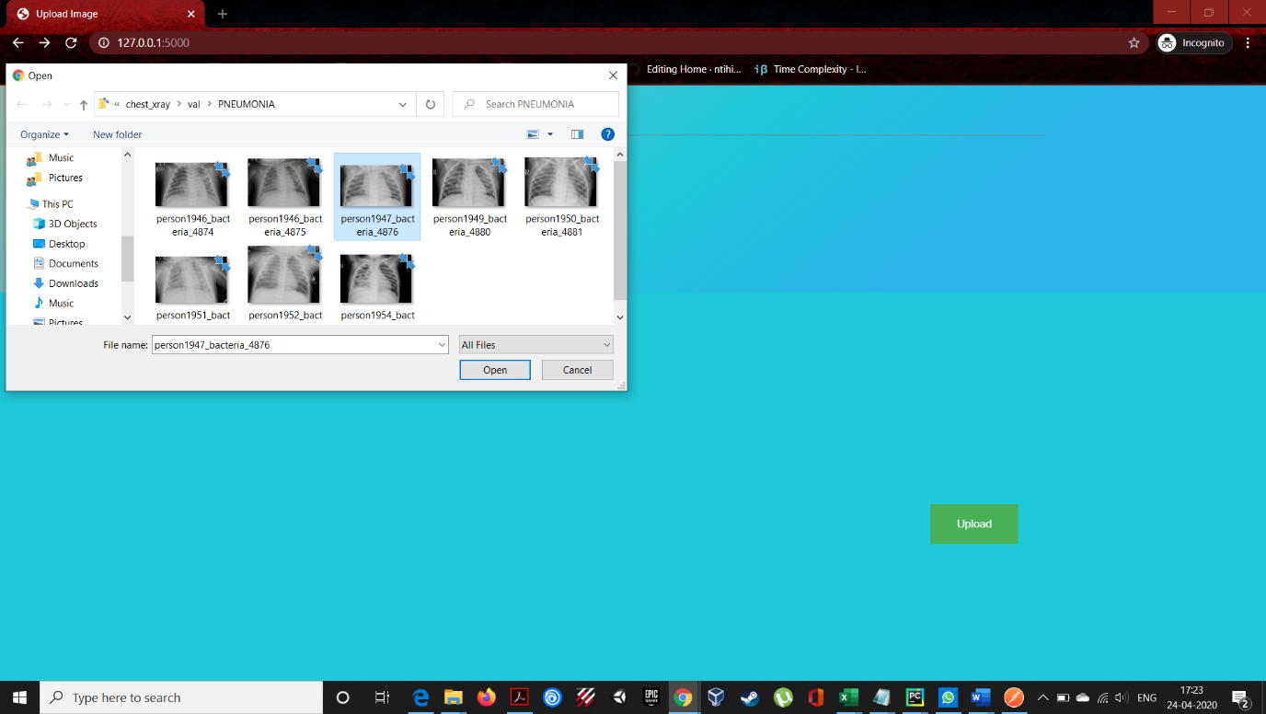

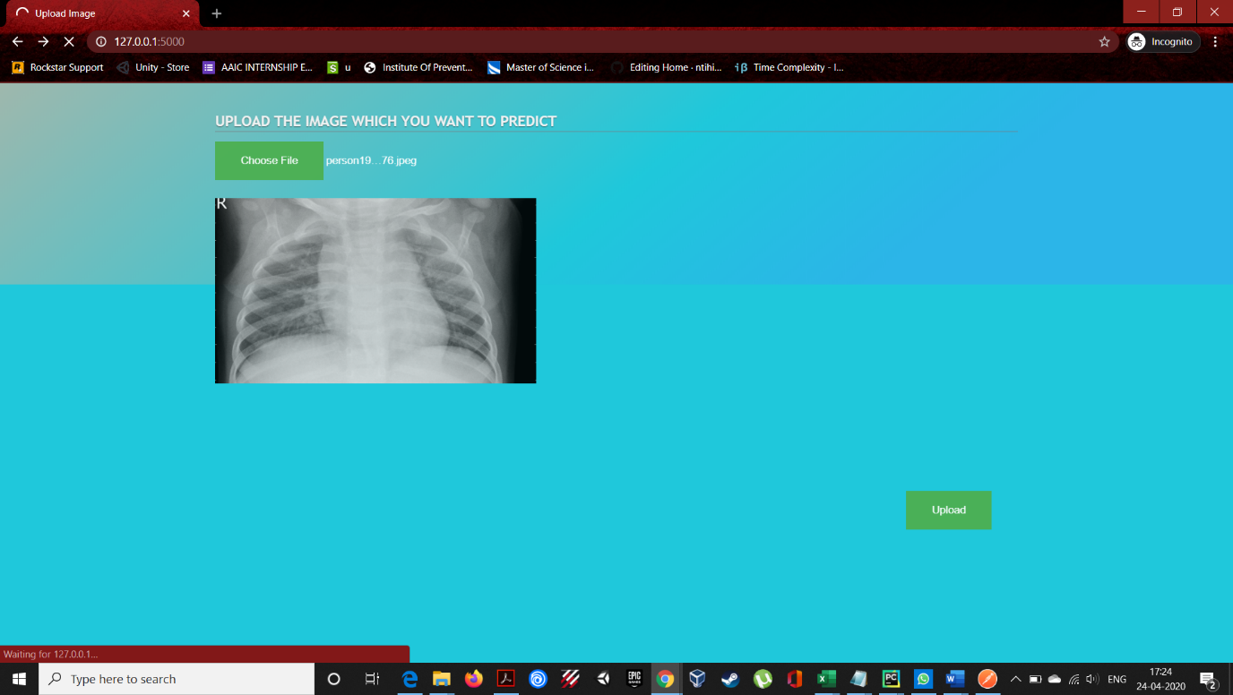

3. FINAL RESULT

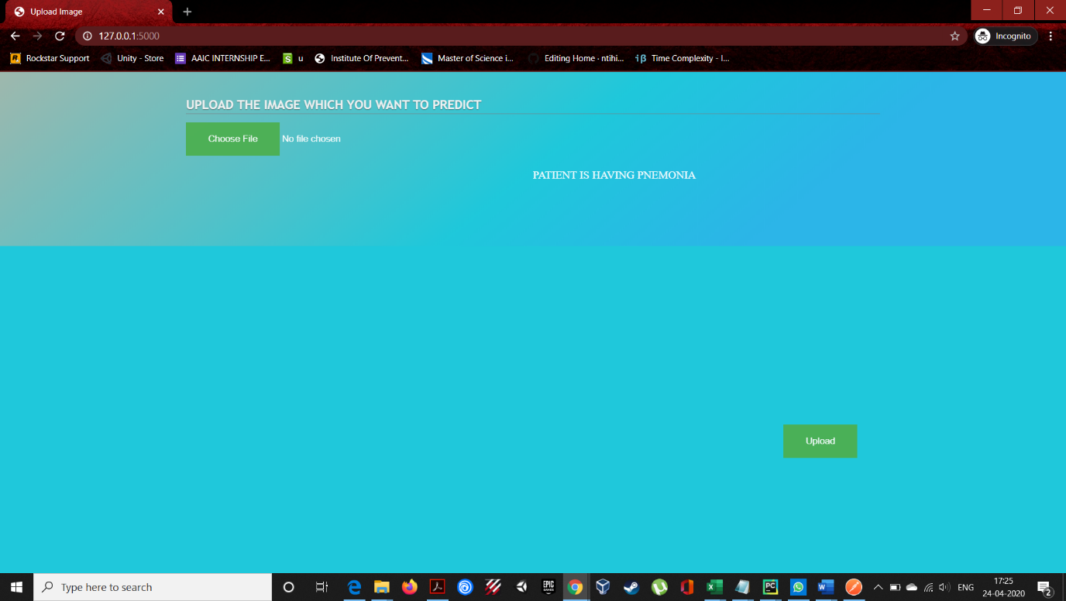

* Please find the code snippets for the API call from angular.

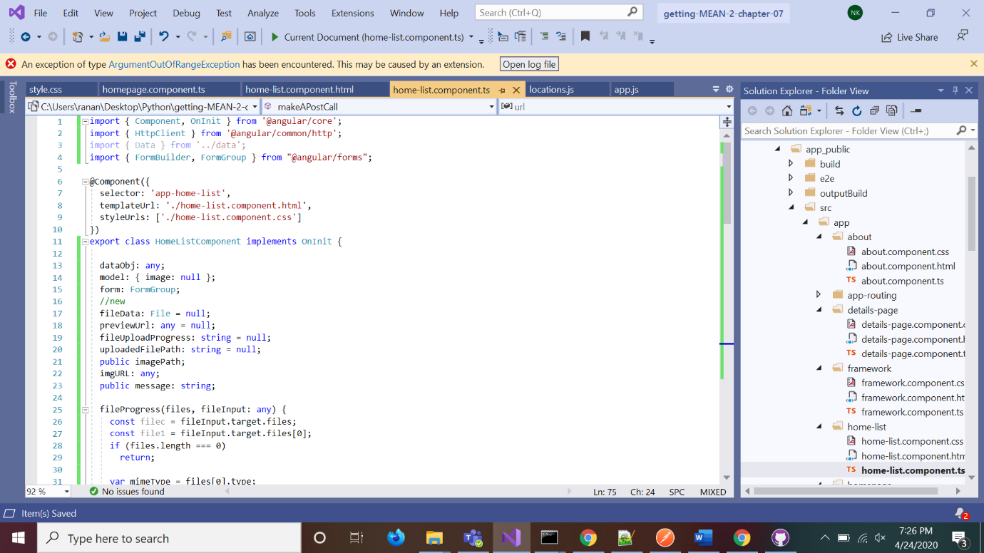

* Reading the file which is taken from the UI

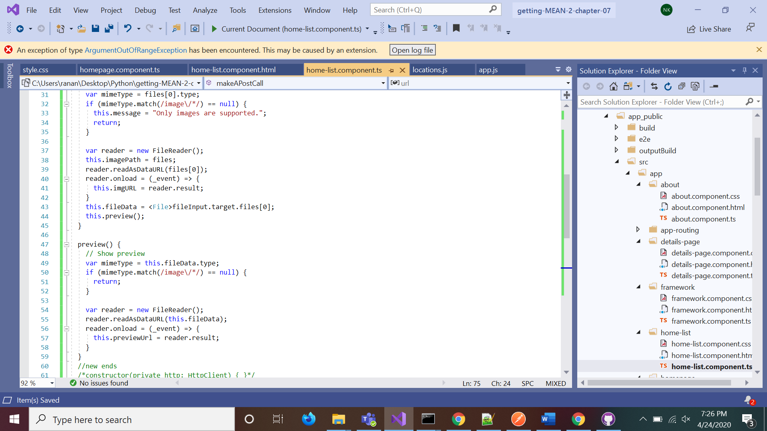

* After reading the file, we are sending the that to the API call.

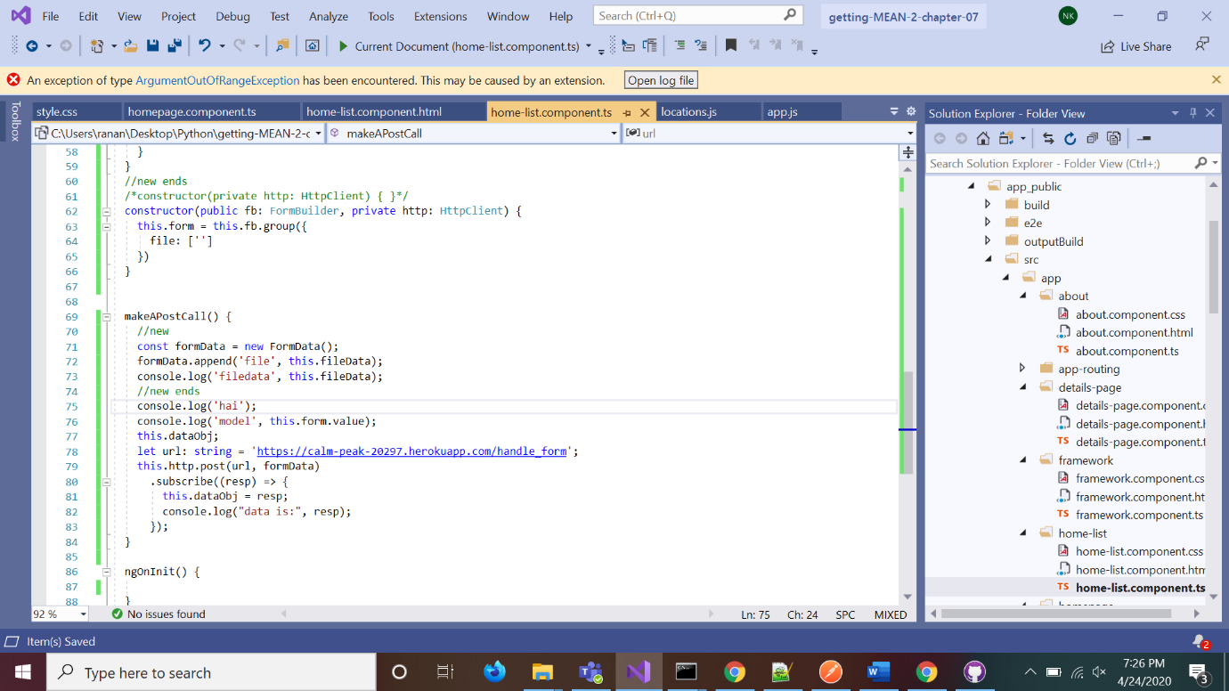

* This is the HTML file.

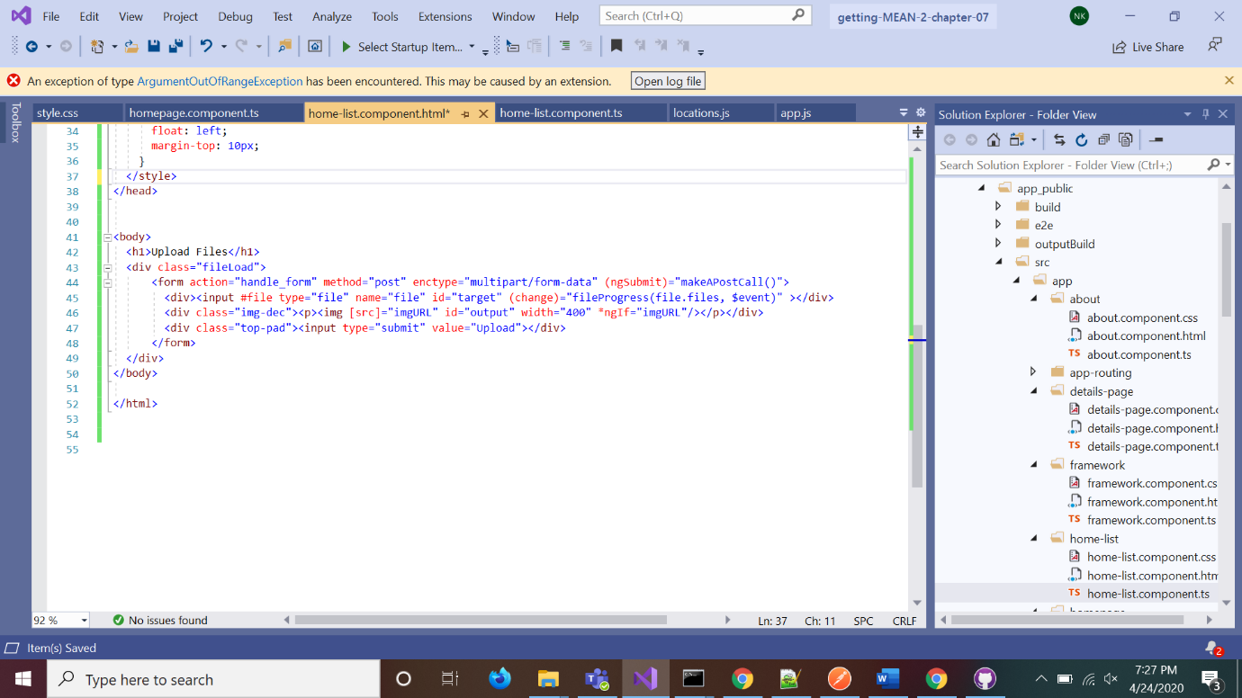

* We are taking the input file in this format to send it to the API call.

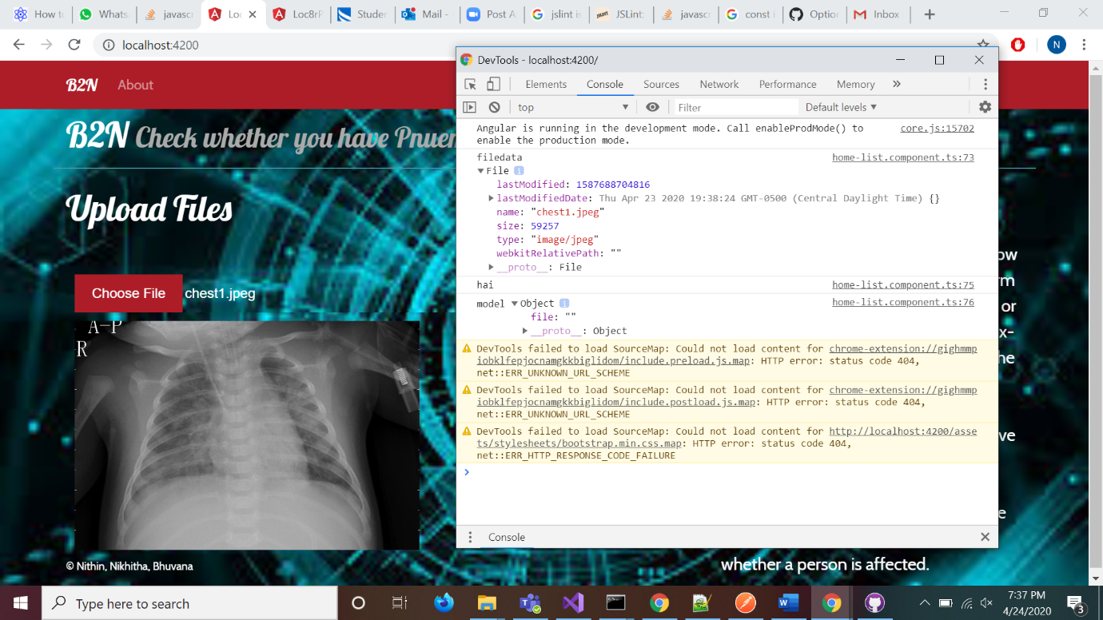

* We are facing the following issue after calling our API.

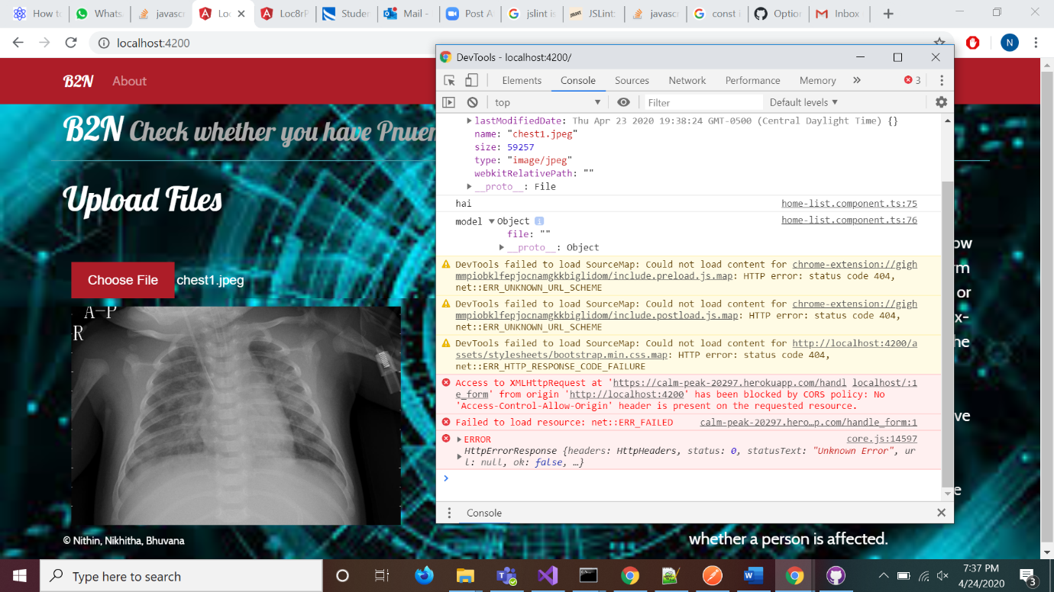

* We have build a new website using angular to upload the Chest X-ray and get the prediction.

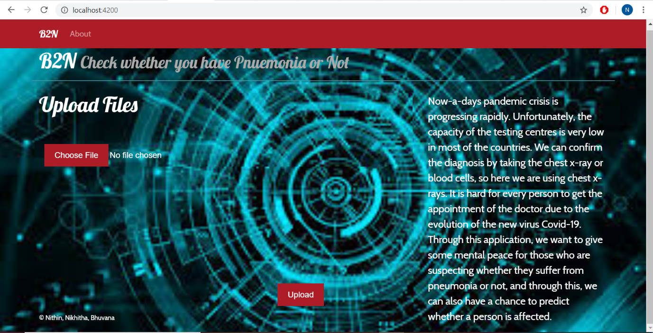

* Once we open the site, there will be a button named Choose File. On clicking it we can select the image from our desktop. The file which we have selected will be displayed below it and the name of the file will get displayed beside the Choose File button.

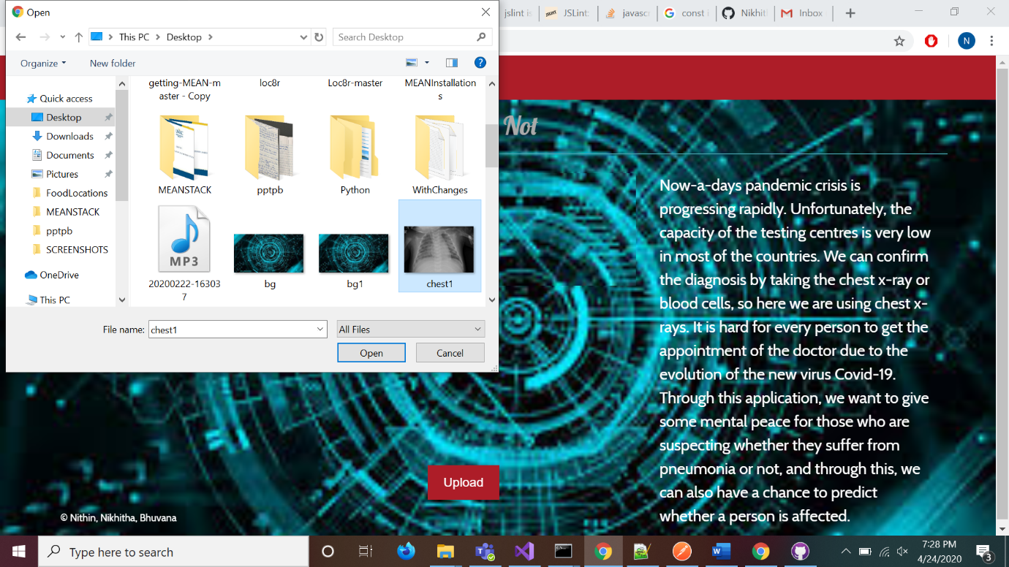

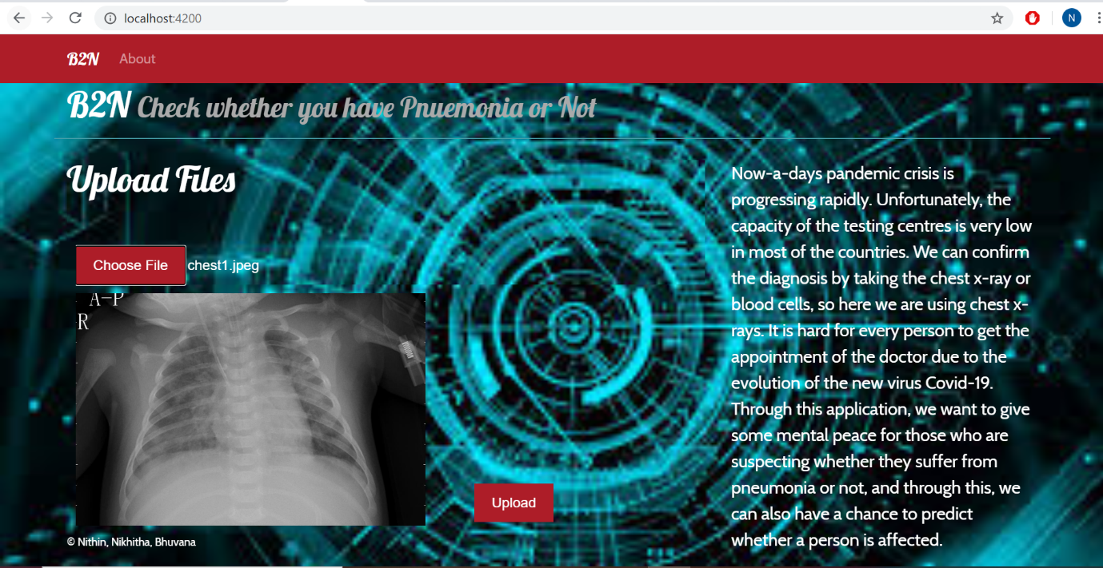

* We also have an about page, which just gives a brief description of our site.

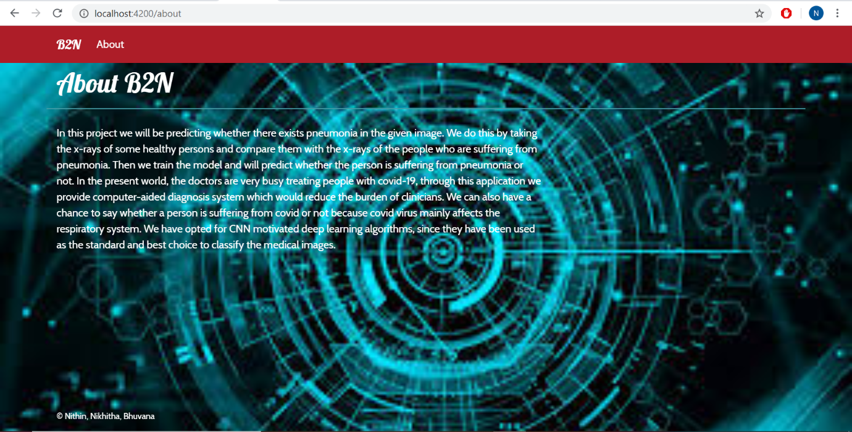

**Version – 3**

**Step 1:**

Reading the data from directory and appending it label and image to a list. While appending it to list we have resized the image to 128,128,3 shape.

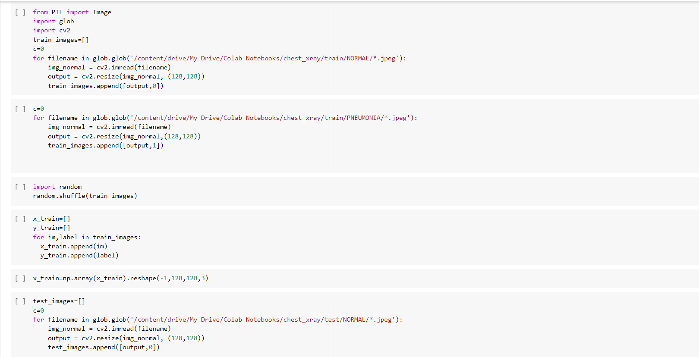

**Step 2:**

After appending the data to list we have shuffled the in-order to make our model less bias.

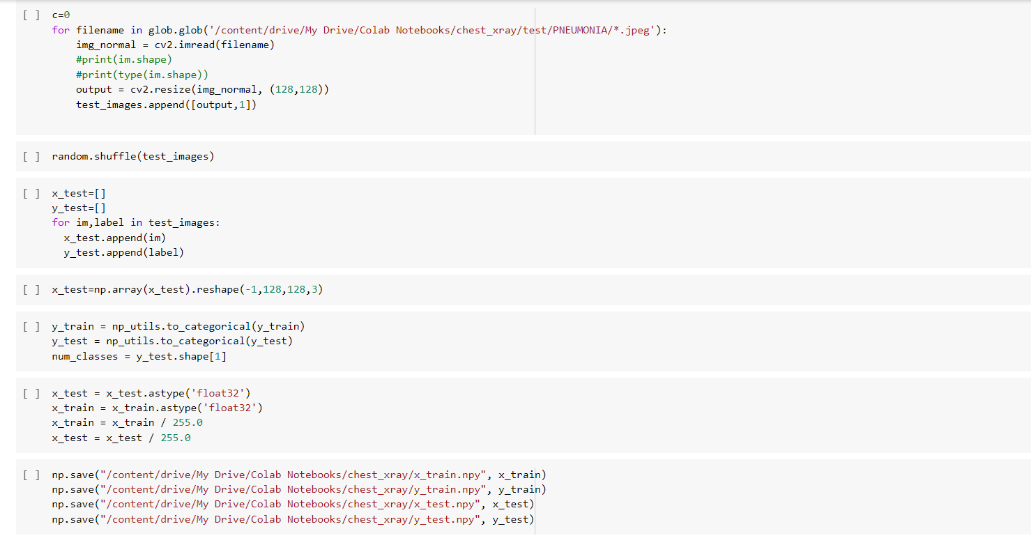

**Step 3:**

After shuffling the data we have divided the label and image and stored into the NumPy array, after storing the data in NumPy array we have scaled the data by dividing each pixel value by 255. We have also one hot encoded the label data.

**Step 4:**

As we have only 5k images we have used ImageDataGenerator to generate more images with different parameter given. We are also using wandb for Keras call back functions.

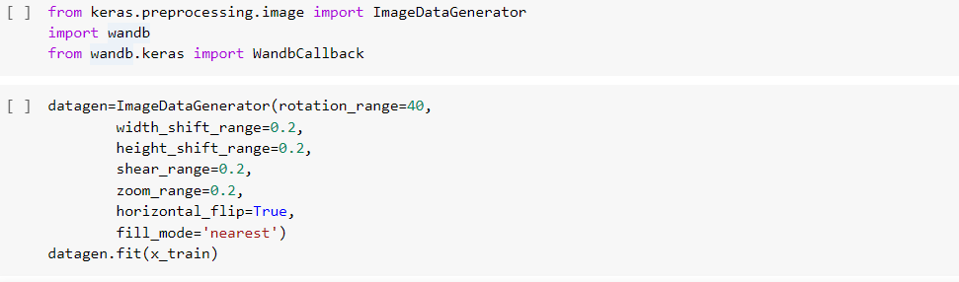

**Step 5:**

In this step we are building our model. In our model we have used two convolutional layers as we are looking for the patterns in our image.

**Step 6:**

In this step we have complied the model. We have used binary_crossentropy as we are looking between two classes. The optimiser that we are using is Adam.

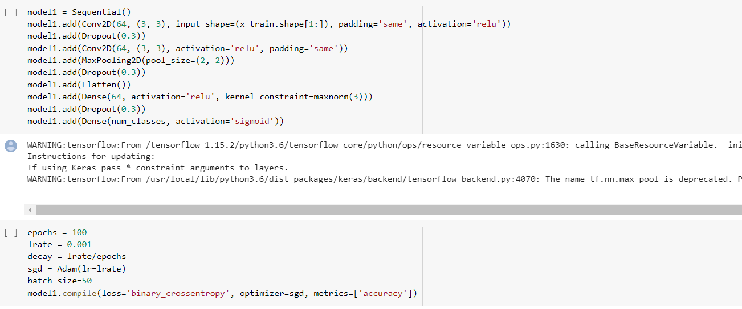

**Step 7:**

In this step we are initiating the wandb for Keras call back and we are also fitting the model by keeping call back as WandbCallback() .

**Step 8:**

In this step we headed to wandb site in order to get best model with best weights that we got in between epochs.



**Step 9:**

In this step we have used the saved model and loaded a image, we have optimised the image to feed it to mode, and we have finally predicted the image. For this model we got accuracy of 84% on validation data.

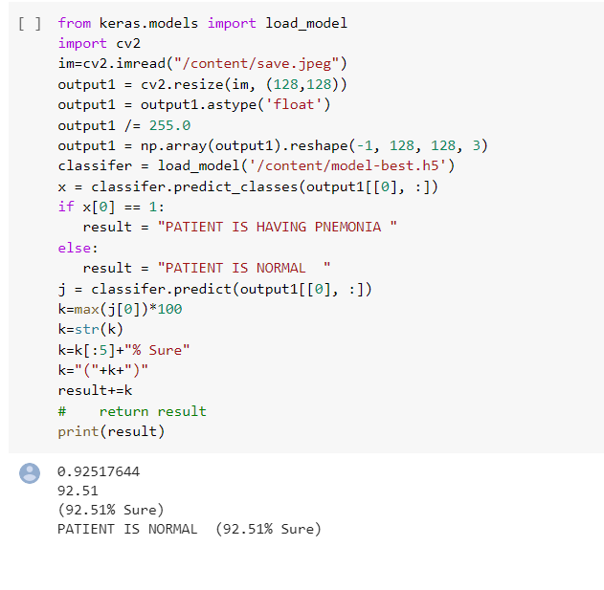

* The next step is the to use the saved model and create a website that takes input image and predicts the output. We use flask for that. Below is the python code for using flask.

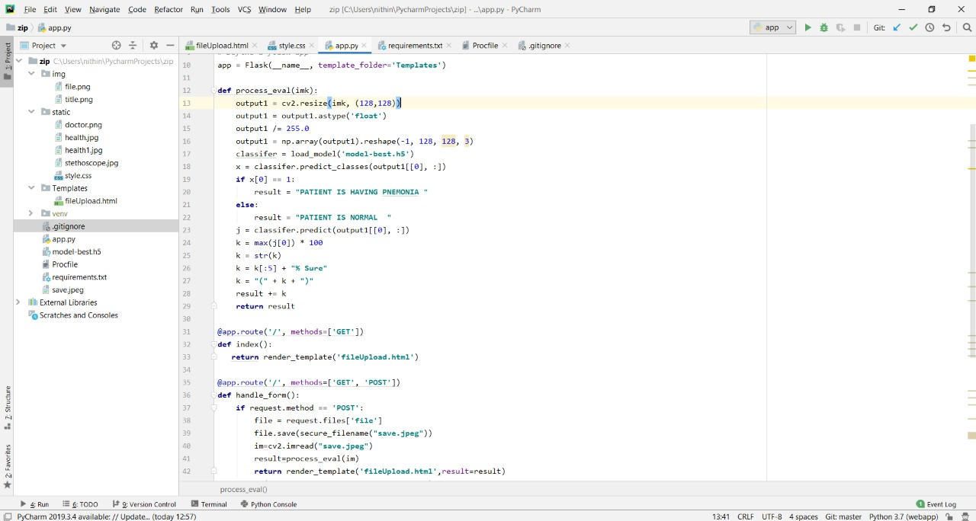

* This is the html file that enables us to select an image from our local and displays the predicted result.

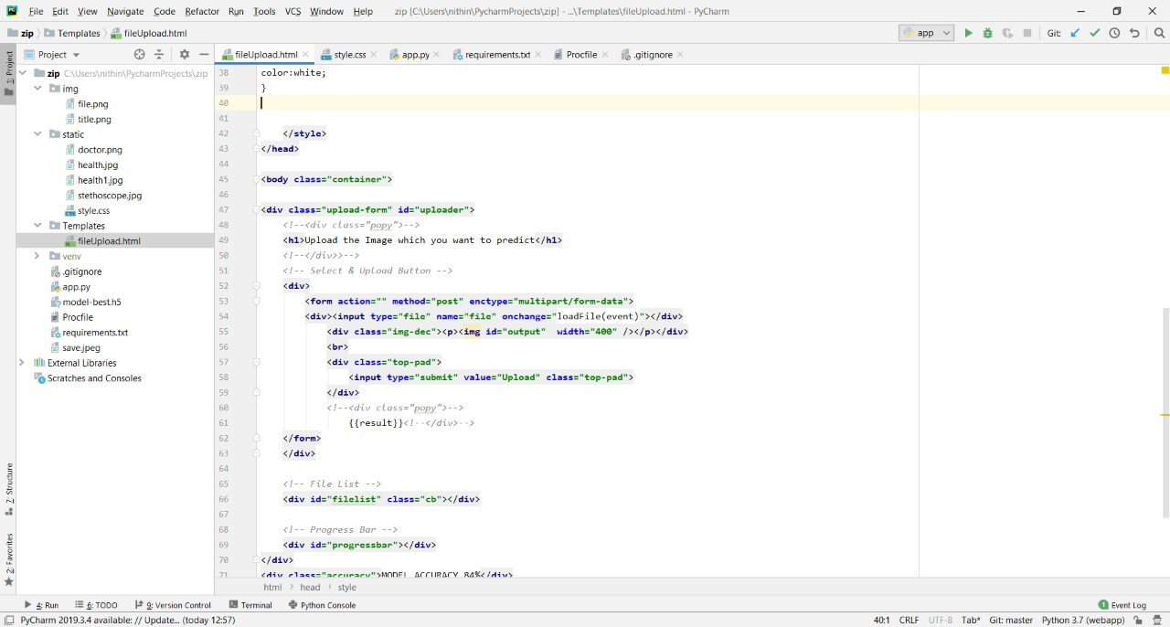

* This is the CSS we have used to style our site.

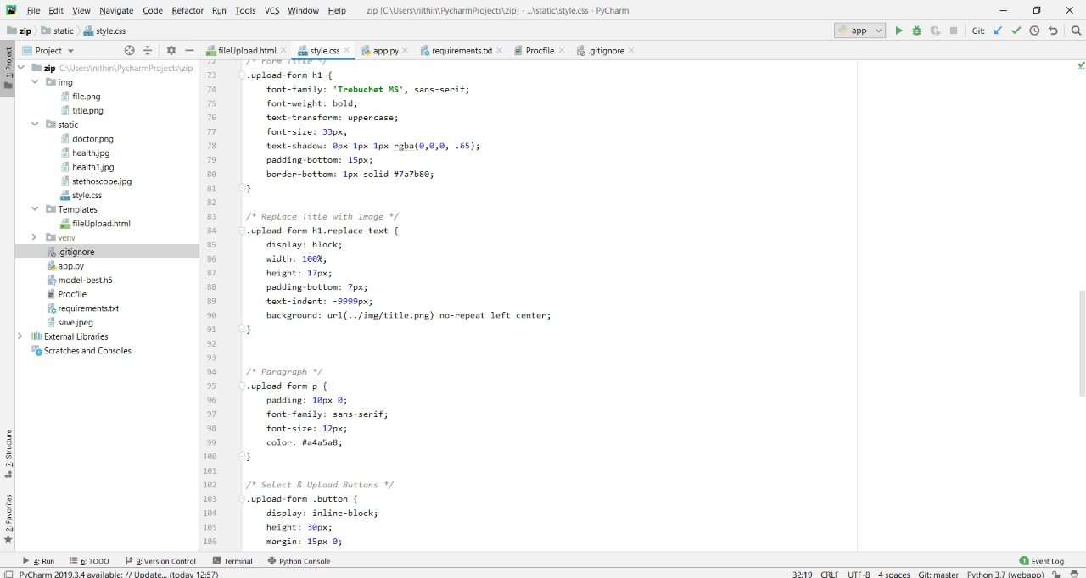

* This is the flask project structure.
* All the css and images should be in the static folder.
* All the html files should be in the Templates folder.
* Procfile, requirements.txt and .gitignore files are used for the Heroku deployment.

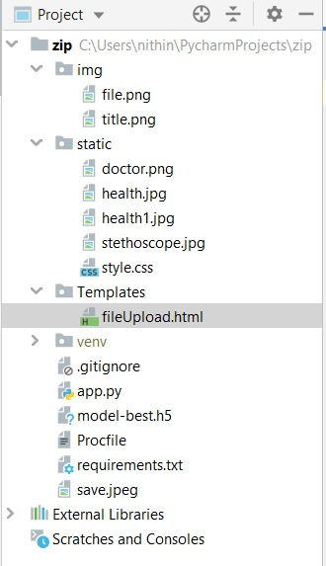

* When we give the command pip freeze, we get the following code. We need to create a requirements.txt and paste the whole code into that file.

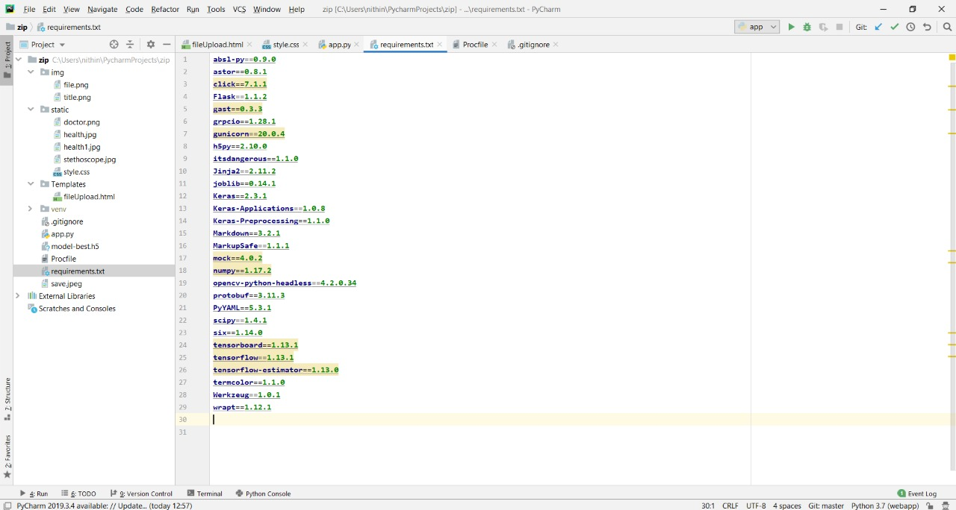

* We need to create a procfile, to tell Heroku how to execute our python file and which file to execute.

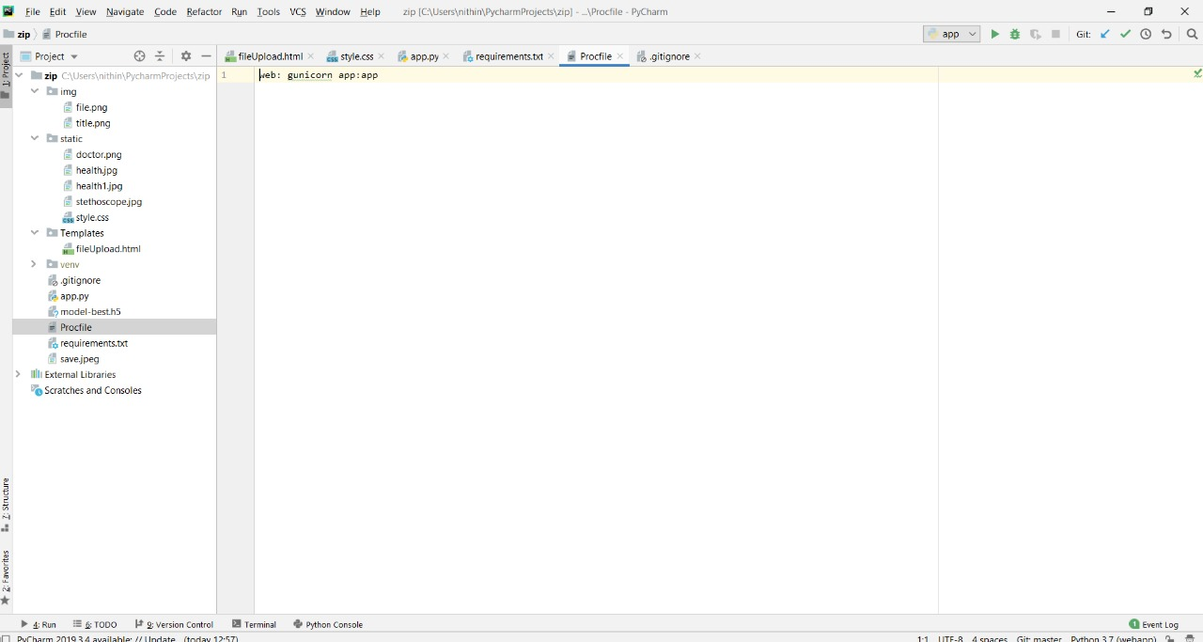

**Deploying in HEROKU:**

* Below are the commands that are used to deploy in Heroku.

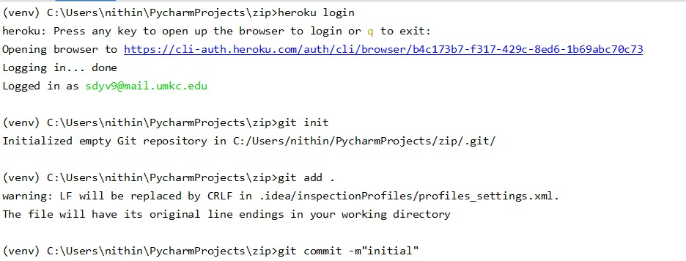

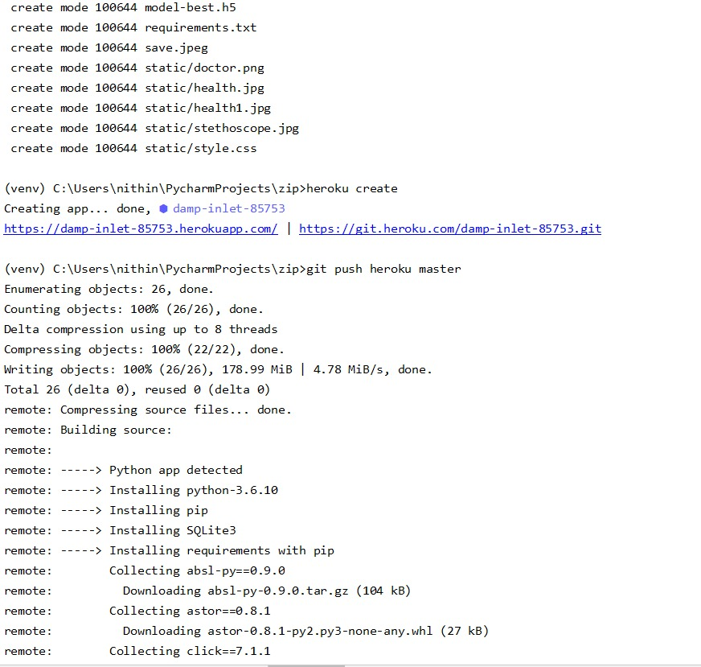



**Website:**

* This is how the website after deploying in Heroku looks like.
* This is the landing page of the site
* Click on the choose file button and select the image from your local system.

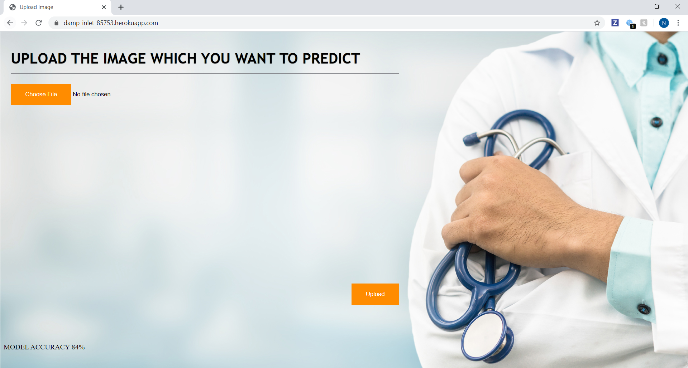

* After you select an image, the selected image gets displayed below the button.

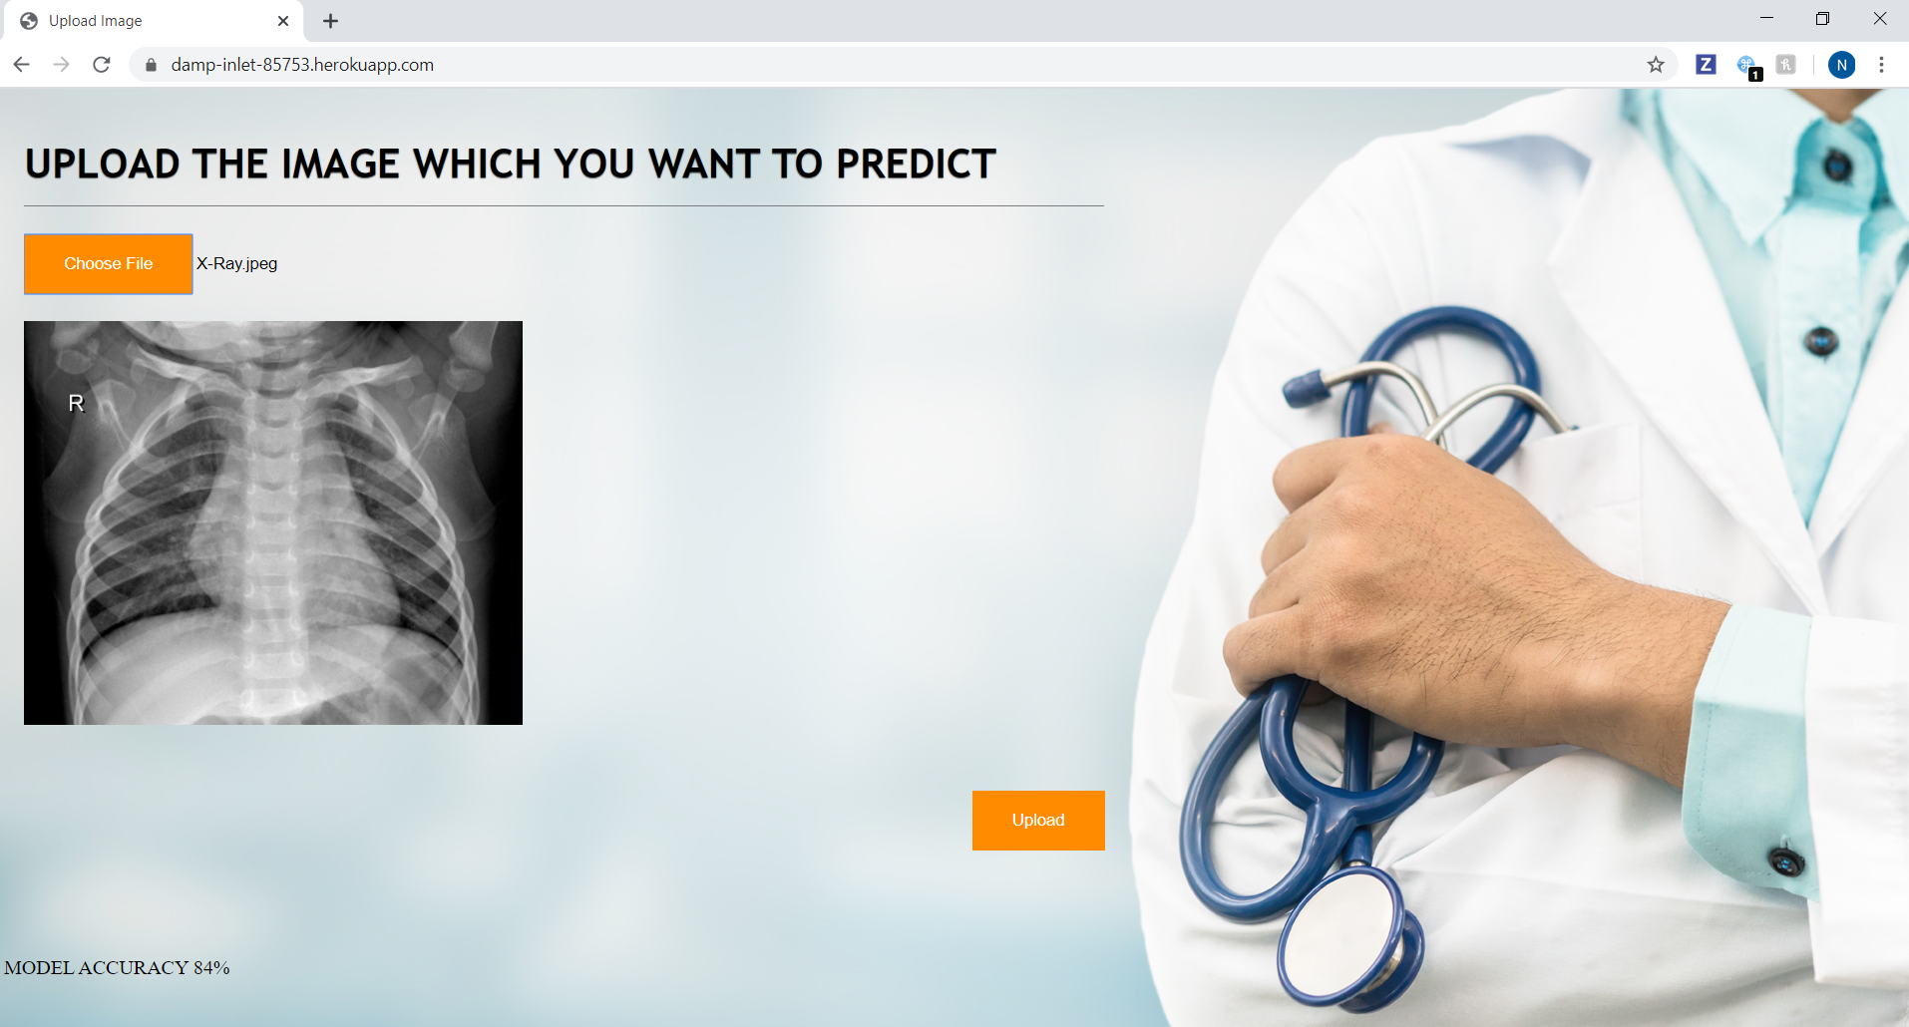

* Now you need to click on the upload button, which triggers our model and displays the predicted result on the screen.

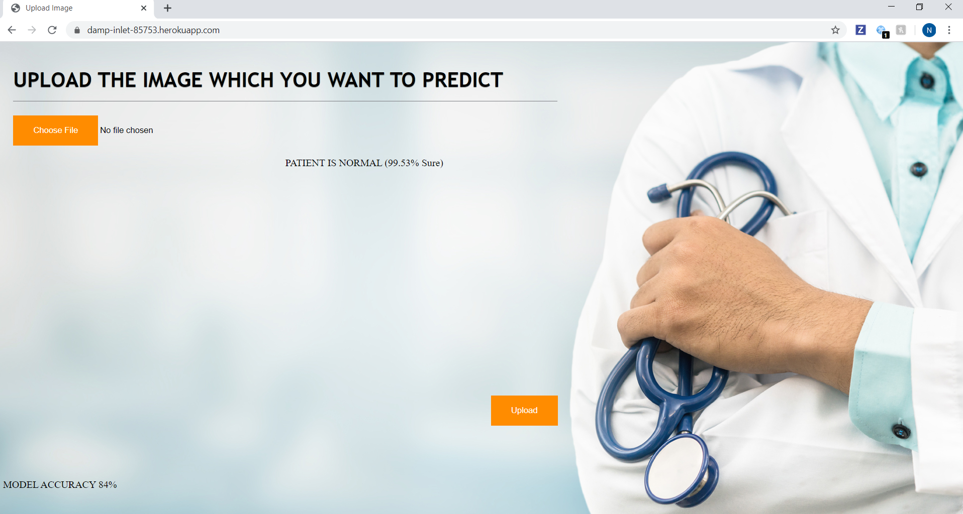

* Wandb
* It's framework-agnostic and lighter than TensorBoard. Each time you run a script instrumented with wandb, we save your hyperparameters and output metrics. Visualize models over the course of training, and compare versions of your models easily. We also automatically track the state of your code, system metrics, and configuration parameters.
* Below are the charts of val_loss, val_accuracy, loss, epoch and accuracy that wandb has created for the project.

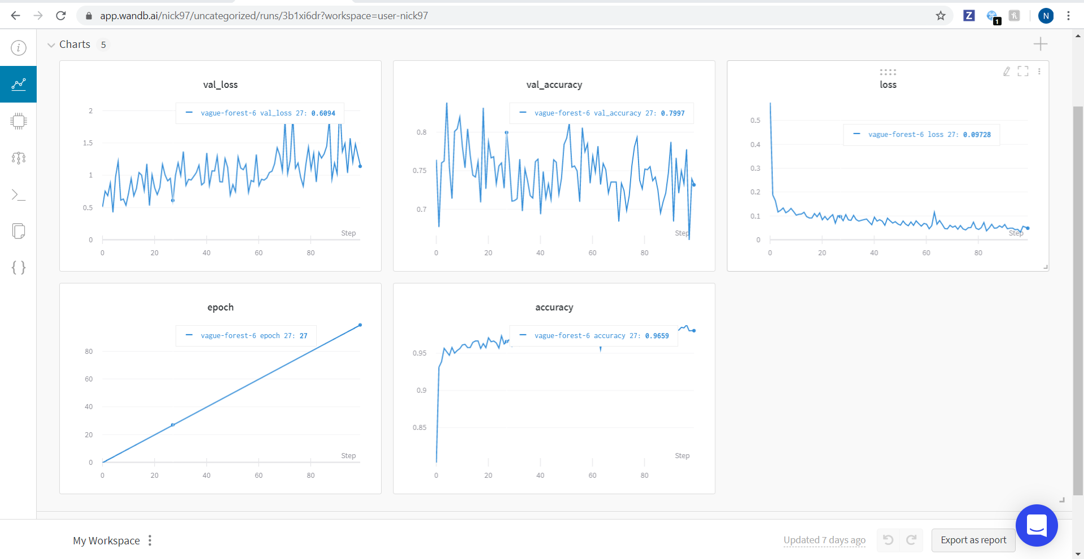

* Wandb displays the system usage.

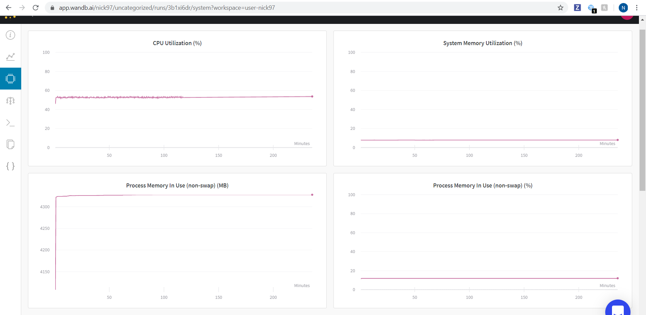

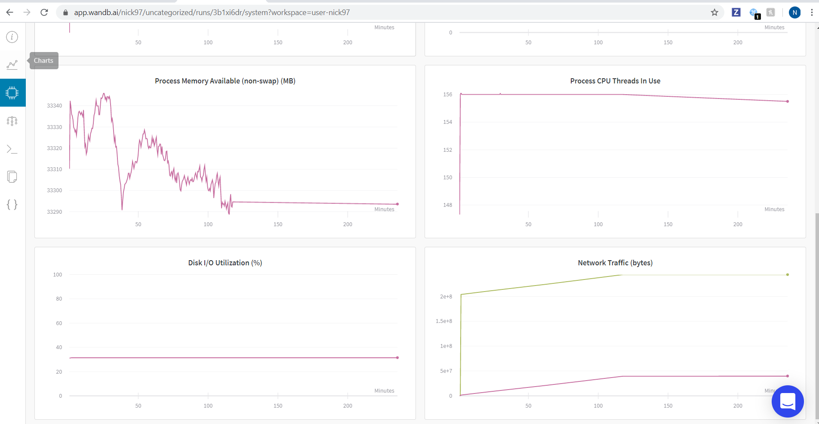

* Wandb displaying the model we have used.

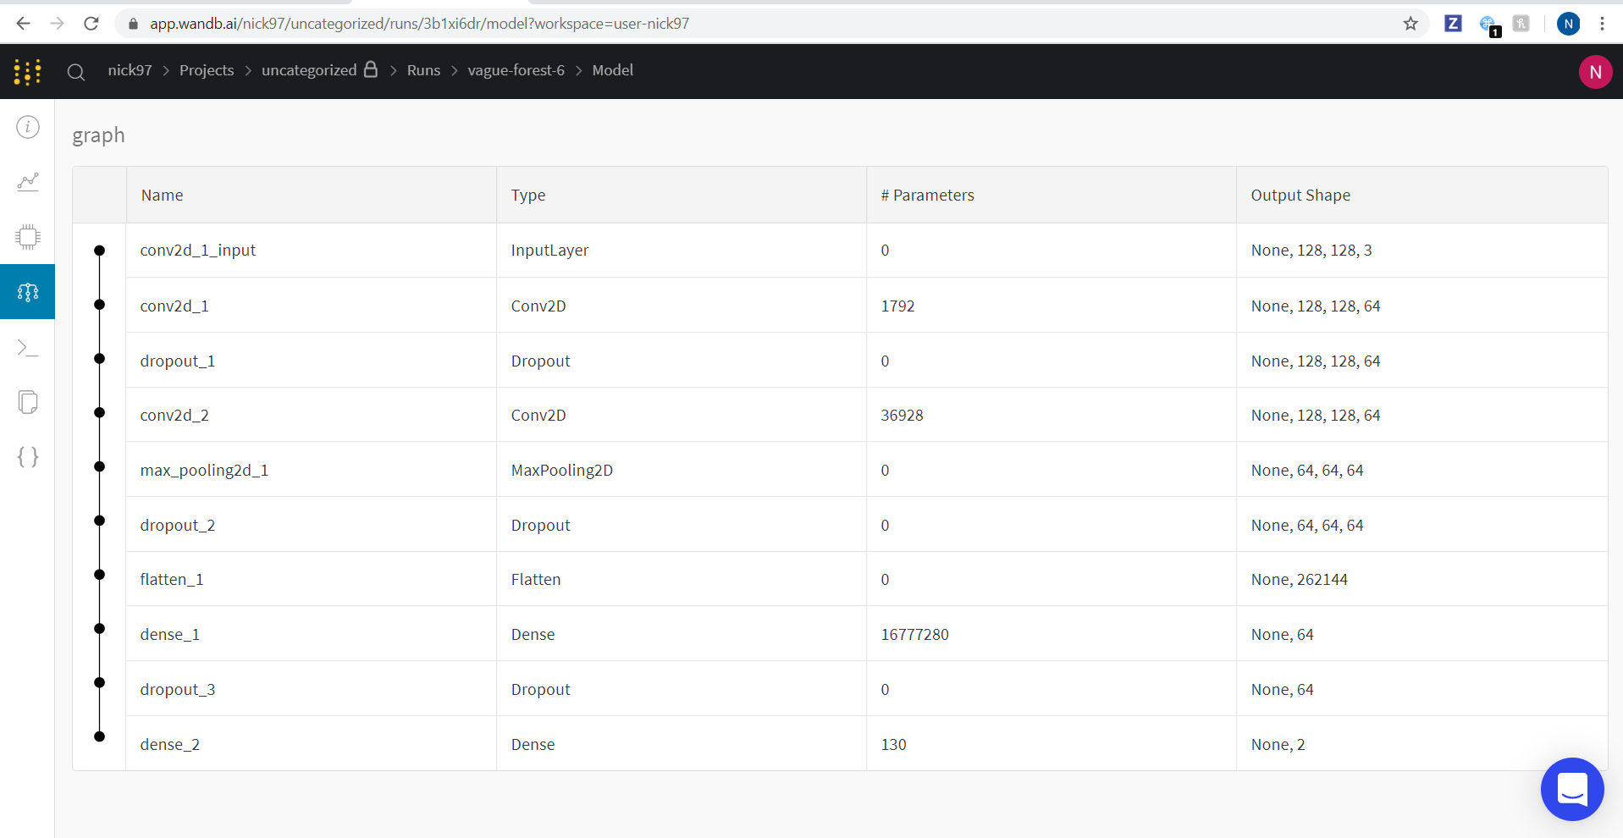

* Wandb disaplying the files it have created for us.
* Using these it would be easy for us to deploy in AWS.

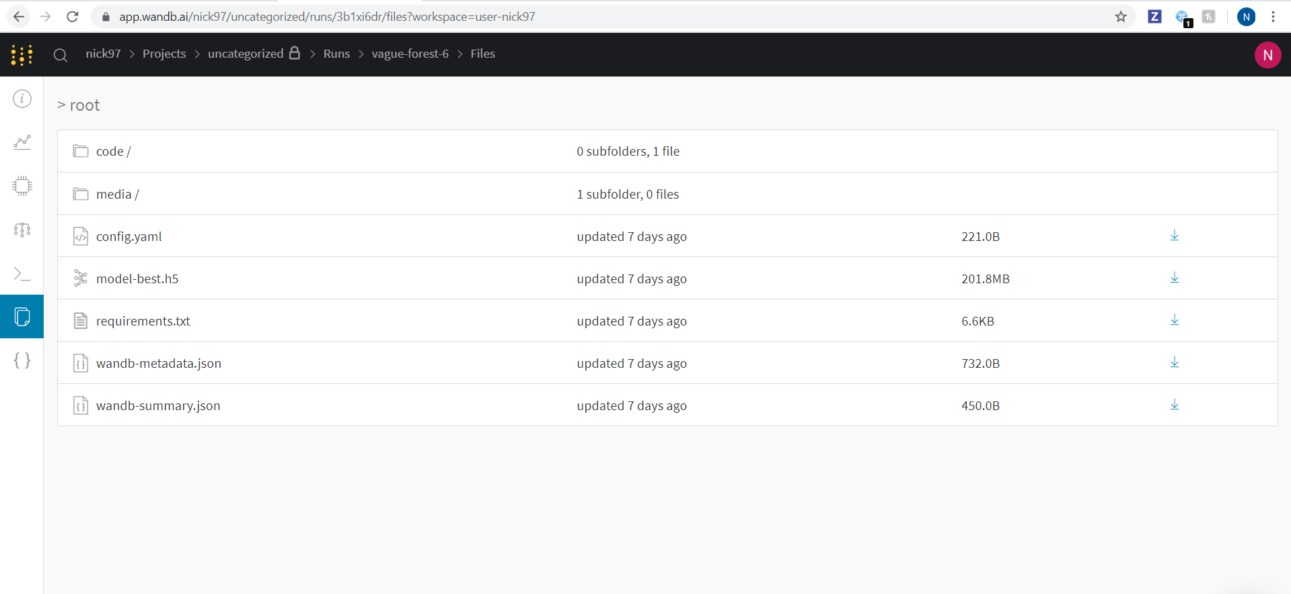

* This is the API call for our model done in POSTMAN.

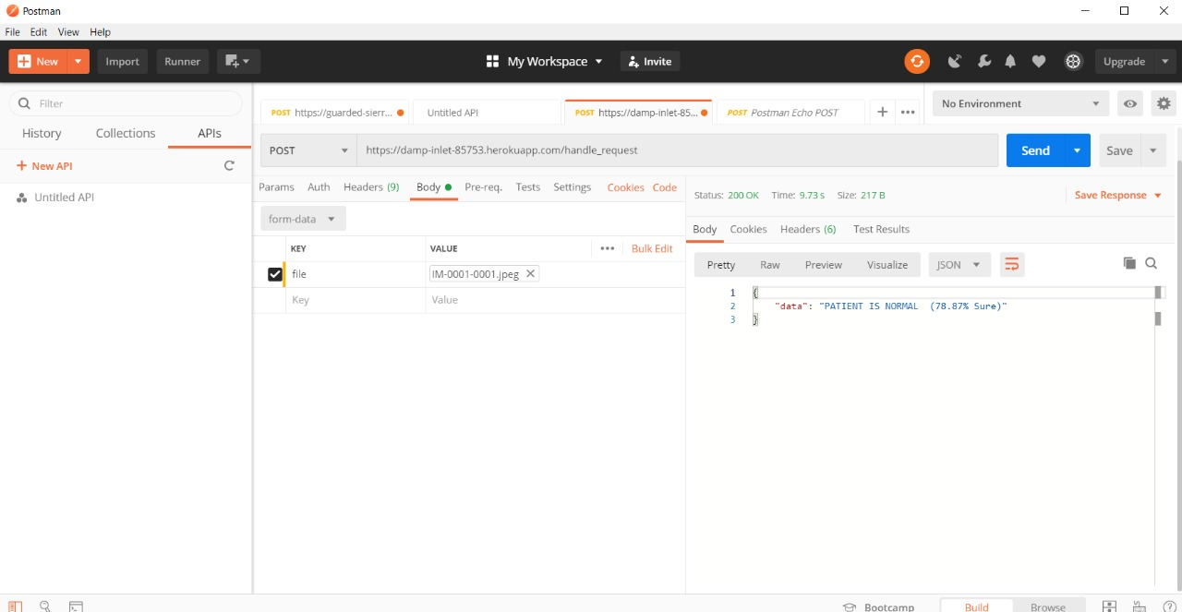

**CHALLENGES FACED:**

1. We have several issues while facing the data of image where we had to shrink the image in order to satisfy memory and session crash. We had a difficult time in finding the right size of image which will not crash the session and train our model in efficient way for right prediction.
2. The major challenge that we had to deal with is the slug size. We had a problem where we are running out of slug size because of TensorFlow size and our model size we have reduced the compiler size of TensorFlow by down grading it version, and we have used Wandb as a call back which helped us in shrinking the size of model .
3. We also faced a issue of overtime in training our model we have figured it out by re sizing the number of neurons in each layer, we have introduced some dropout layer for faster computation.
4. we also had an issue in prediction of data as we were dealing with sensitive data we need to be sure all aspects. we have solved this issue by using Image generator form keras to generate more images for efficient training of our model.

**FUTURE SCOPE:**

Our main motive of this project is to set up a application which can help hospital administration to priorities appointment to patients who are in more need than who are good in health condition. For this we have deployed this our application as a rest API which can be used in any web applications for new system design.

**REFERENCES:**

https://keras.io/

<https://www.tensorflow.org/tutorials/images/classification>

https://towardsdatascience.com/wtf-is-image-classification-8e78a8235acb

<https://www.youtube.com/watch?v=j-3vuBynnOE>

<https://www.youtube.com/channel/UCWN3xxRkmTPmbKwht9FuE5A>

https://www.tensorflow.org/